[](https://www.tutorialr.com/workshops/)

Blazorfy

Blazor × Spotify





# Contents

Contents

Setup 3

.NET 3

Project 4

Packages 5

Visual Studio Code 6

Start 7

Workspace 7

Extension 8

Settings 9

Imports 10

Provider 11

Namespaces 12

Class 13

Program 14

Authentication 15

Account 15

Constants 21

Members 22

Methods 22

Constructor 23

Property 23

Login 24

Logout 24

Logged In 25

Handle Code 26

User 26

Component 27

Index 29

Library 33

Categories 33

Playlists 42

Albums 54

Podcasts 64

Finish 72

Blazor 72

Spotify 73

Summary 74

# Setup

## .NET

**.NET** includes **Blazor** so you will need to **Download** and **Install** the latest version of the **.NET SDK**, which if you don’t have it already you can **Download** it for **Windows** or **Mac** using a new **Browser** tab at [dot.net](https://dot.net)

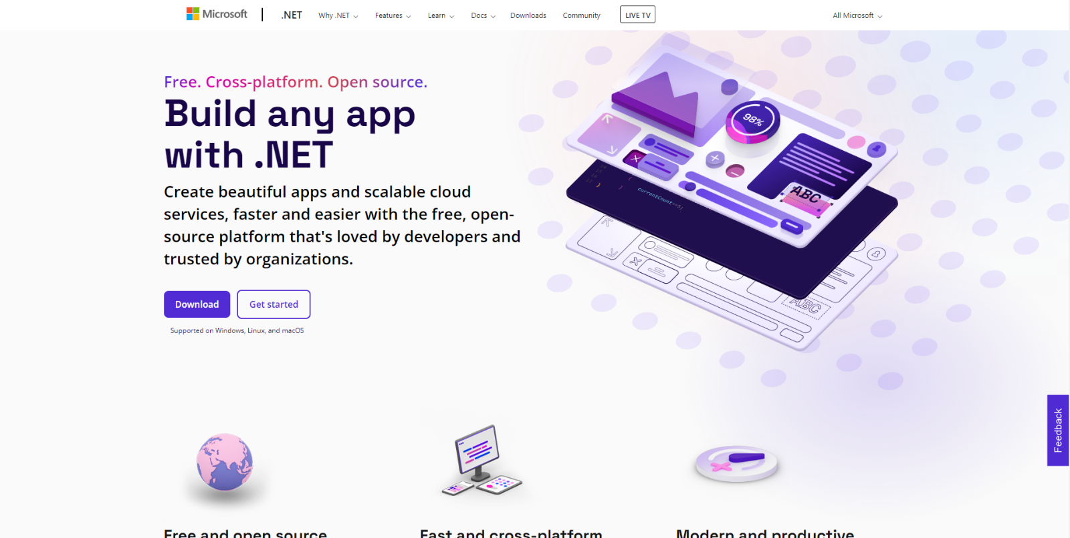

Once **Downloaded** you can open to **Install** the **.NET SDK** by following the steps in the **Installation Wizard**

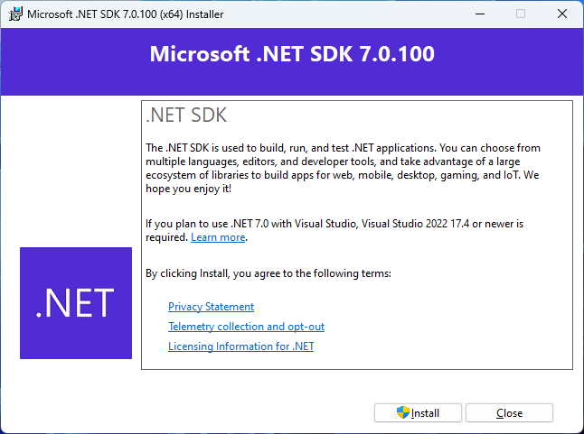

## Project

If the **.NET SDK** has been **Installed**, then if using a **Mac** you then need to go to **Finder** then search for **Terminal** and then select it or if using **Windows** you need to go to **Start** then search for **Command Prompt** and then select it so it launches as follows:

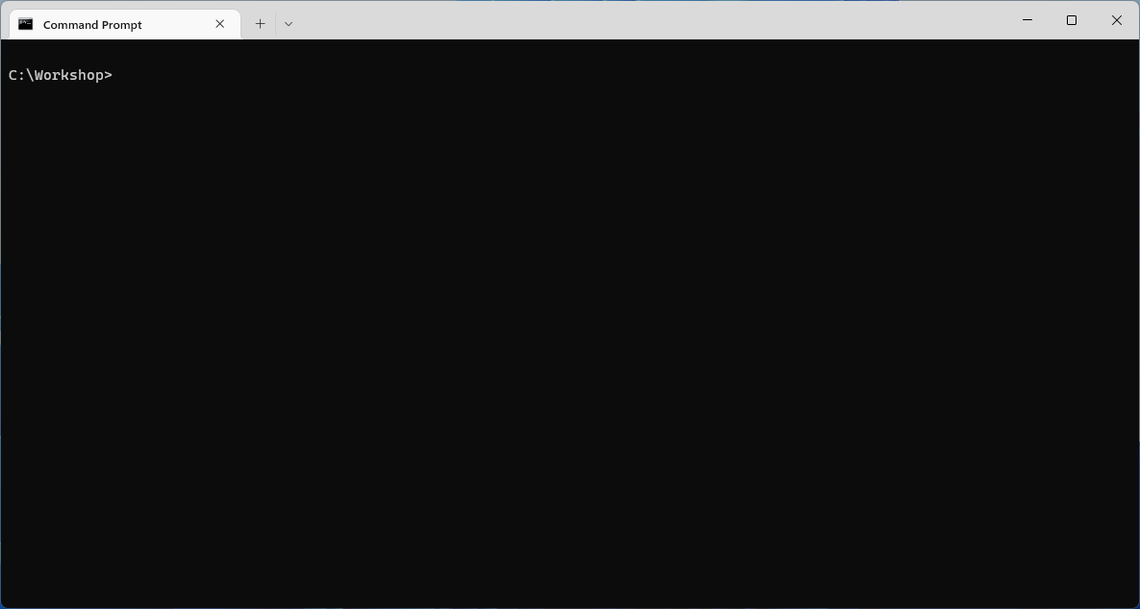

Once in the **Command Prompt** or **Terminal** you will need to create a new **Folder**, you can use **mkdir** followed by the name of the **Folder** e.g. *Workshop* and then press **Enter**.

mkdir Workshop

Then you will need to switch to this **Folder**, to do this from the **Command Prompt** or **Terminal** type in the following command and then press **Enter**:

cd Workshop

Once in this **Folder** you can create a new **Project** using the **.NET CLI** that was **Installed** as part of the **.NET SDK**. While still in the **Command Prompt** or **Terminal** type in the following and then press **Enter**:

dotnet new blazorwasm -o Blazorfy

This will create a new **Project** for **Blazor** using **WebAssembly** or **wasm**. Once the **Project** has been created in the **Command Prompt** or **Terminal** you will need to change to the **Folder** for the **Workshop** by typing in the following and then press **Enter**:

cd Blazorfy

Please make a note of the **Folder** where you have created the **Project** e.g. *C:\Workshop\Blazor* for later in the **Workshop**.

## Packages

While still in the **Command Prompt** or **Terminal** you will add some **Packages** that will be used in **Blazorfy** to add the first **Package** of *Blazored.LocalStorage*, type the following and then press **Enter**:

dotnet add package Blazored.LocalStorage

This will add the **Package** for *Blazored.LocalStorage* created by *Chris Sainty* which provides access to local storage for **Blazor** applications, this will be used to save and load values in the **Browser**.

Then while still in the **Command Prompt** or **Terminal** you can add the second **Package** of *Spotify.NetStandard* type the following and then press **Enter**:

dotnet add package Spotify.NetStandard

This will add the **Package** for *Spotify.NetStandard* created by *Peter Bull*which provides access to the **Spotify Web API** and will be used to obtain information from **Spotify**.

You can then close this **Command Prompt** or **Terminal** as it will no longer be needed in the **Workshop**.

## Visual Studio Code

**Visual Studio Code** is a free **Integrated Development Environment or IDE** created by **Microsoft** and will be used in the **Workshop** and will make writing the application easier. You can **Download** it, if you don’t have it already,for **Windows** or **Mac** from a new **Browser** tab [code.visualstudio.com](https://code.visualstudio.com/)

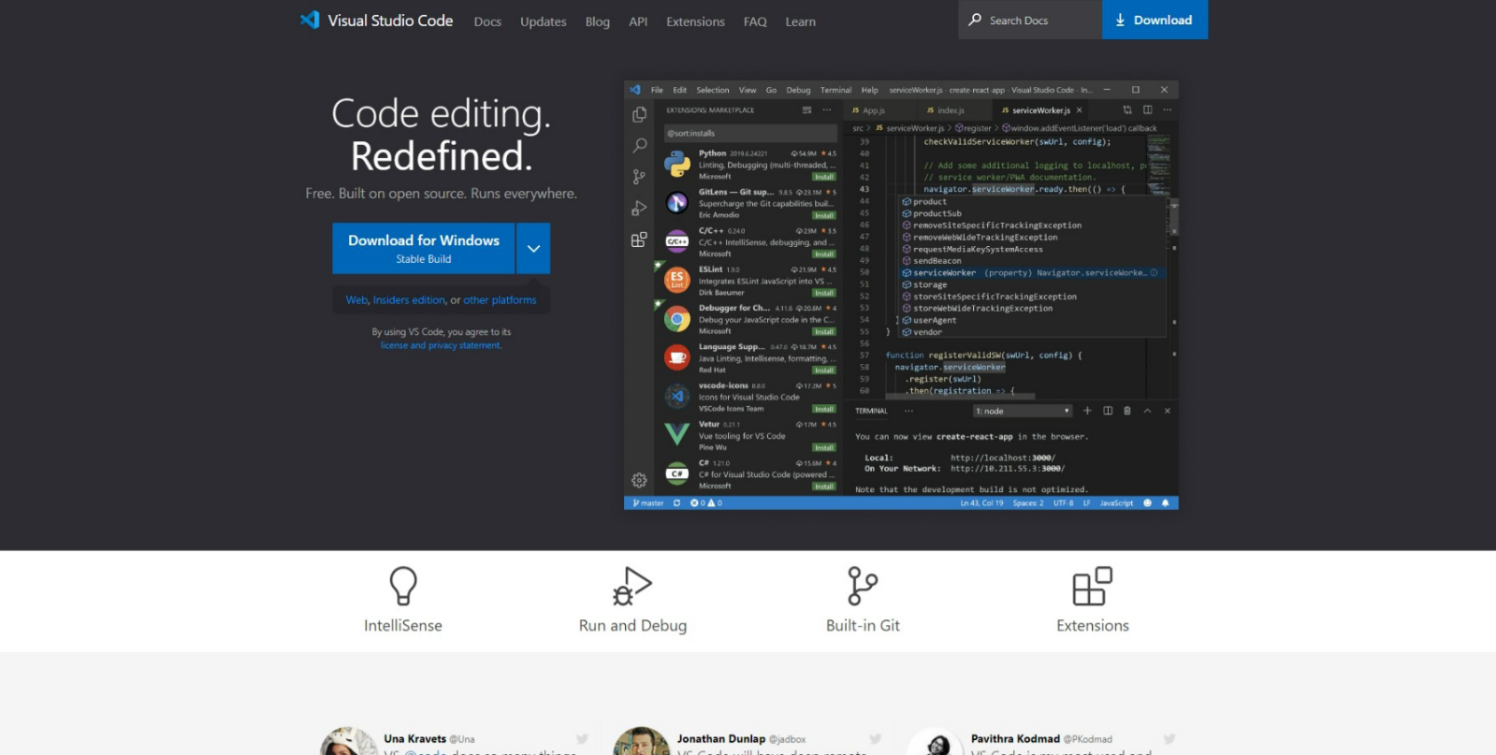

Once it has been **Downloaded,** you can then **Install** itby following the steps in the **Installation Wizard**

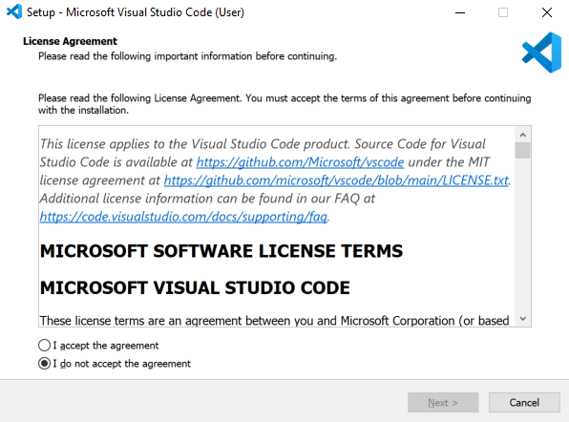

Once you’ve installed **.NET**, used **dotnet new blazorwasm -o Blazorfy**, added the **Packages** and installed **Visual Studio Code** then you’re ready for the **Workshop**.

# Start

## Workspace

Once **Visual Studio Code** has been **Installed**, or was already **Installed** but if it is not already running then if using **Windows** you need to go to **Start** then search for **Visual Studio Code** and then select it or on **Mac** locate it using **Finder** and you should see it loaded with a screen similar to this for **Visual Studio Code**.

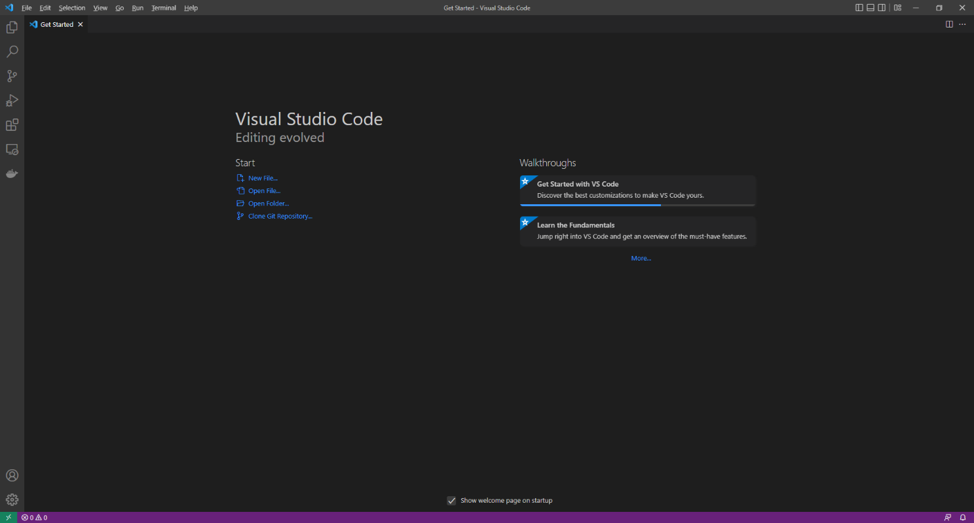

Once **Visual Studio Code** has opened from the **Menu** choose **File** then **Open Folder...** then select the **Folder** for your Application e.g. *C:\Workshop\Blazorfy*. Then to open the **Folder** choose **Select Folder** then one it has been opened Select the **Yes, I trust the authors** option in the **Do you trust the authors of the files in this folder?** if this is displayed which will open the **Workspace**.

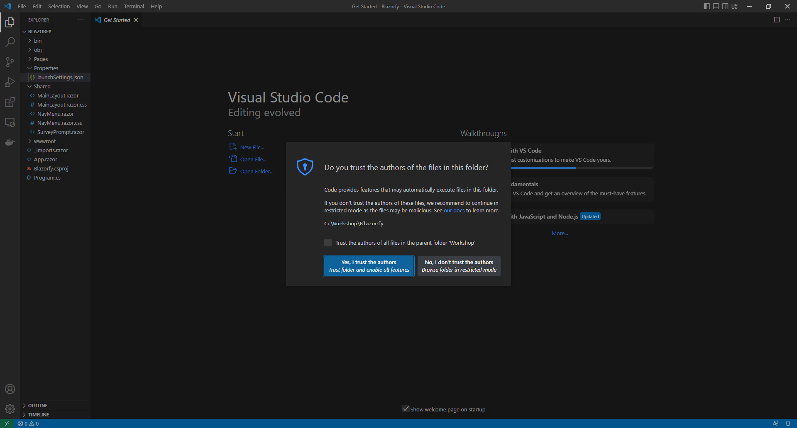

## Extension

Then in **Visual Studio Code** select the **Extensions** option from the **Sidebar** then under **Recommended** and then **Install** the **Extension** for **C#** from **Microsoft**:

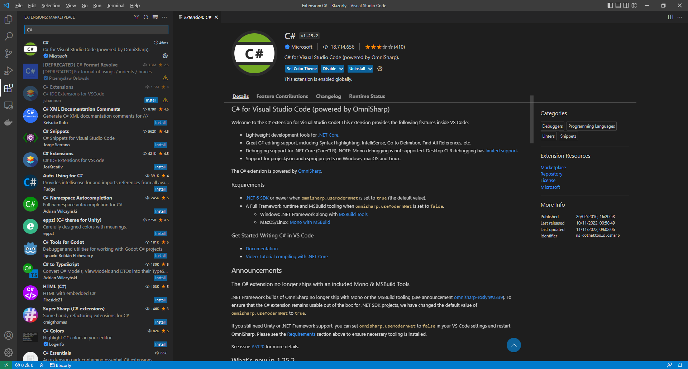

Then once the **Extension** has been installed then you can select the **Explorer** in **Visual Studio Code**

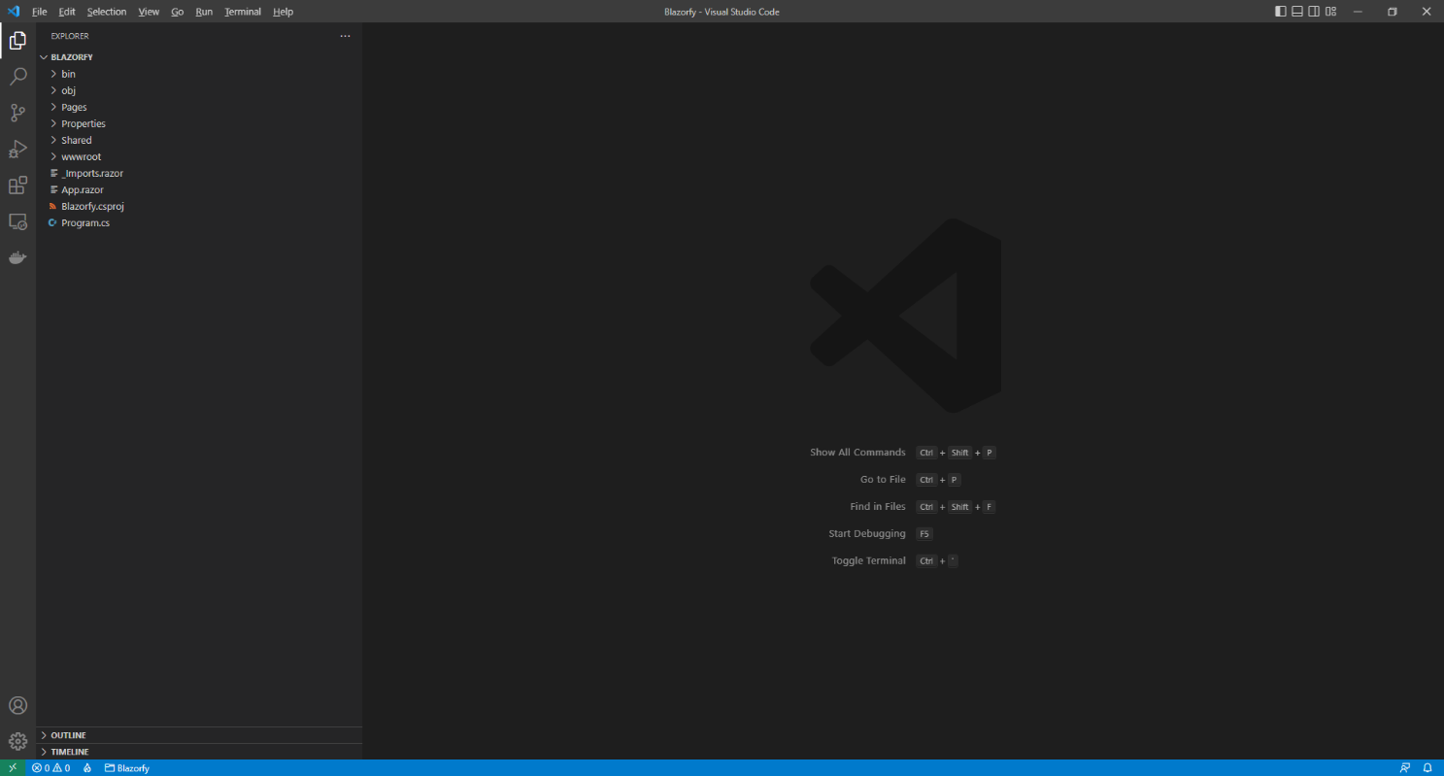

## Settings

While still in **Visual Studio Code** from the **Explorer**, which should be the top option from the **Sidebar** in **Visual Studio Code** for **Blazorfy** open **Properties** by selecting the **>** next to it in **Explorer** and select **launchSettings.json** as follows:

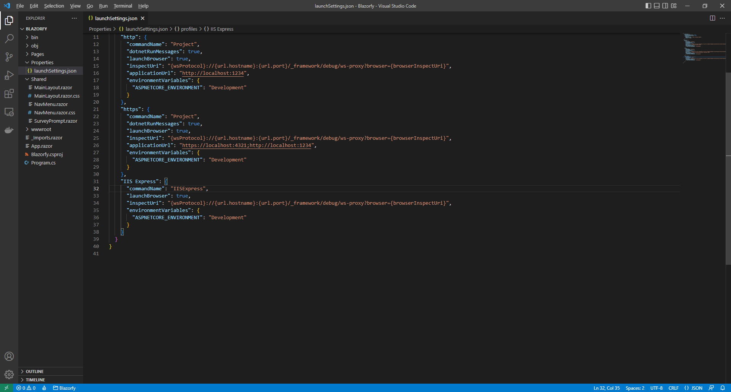

Once **launchSettings.json** has been selected look for **applicationUrl** in **launchSettings.json** there may be more than one, and you will see something like *http://localhost:5107* where the digits may be different. Find anything that starts with **http** in **applicationUrl** and change the number to **1234** e.g. *http://localhost:1234*

1234

Find any entry that starts with **https** within **applicationUrl** and change the number to **4321** e.g. *https://localhost:4321* as follows:

4321

These changes to **launchSettings.json** will ensure when you start the Application that the address it launches is either of the ones for **http** and **https** as this has been set up in the **Dashboard** to be used as the **Redirect URI** in **Spotify for Developers**.

## Imports

While still in **Visual Studio Code** from the **Explorer** for **Blazorfy** select **_Imports.razor** then below **@using Blazorfy.Shared** type in the following:

@using Spotify.NetStandard.Responses

This will allow the **Package** of *Spotify.NetStandard* to be used correctly later in the **Workshop**.

You can then go to the **Menu** in **Visual Studio Code** and select **File** and then **Save All**.

Once done, while still in **Visual Studio Code**, select **Terminal** and then **New Terminal** and then once the **Terminal** has appeared type in the following command and then press **Enter**.

dotnet watch

Once done this will **Build** and **Start** the Application and display it in your **Browser** with *http://localhost:1234* or *https://localhost:4321* in the **Address Bar** as follows:

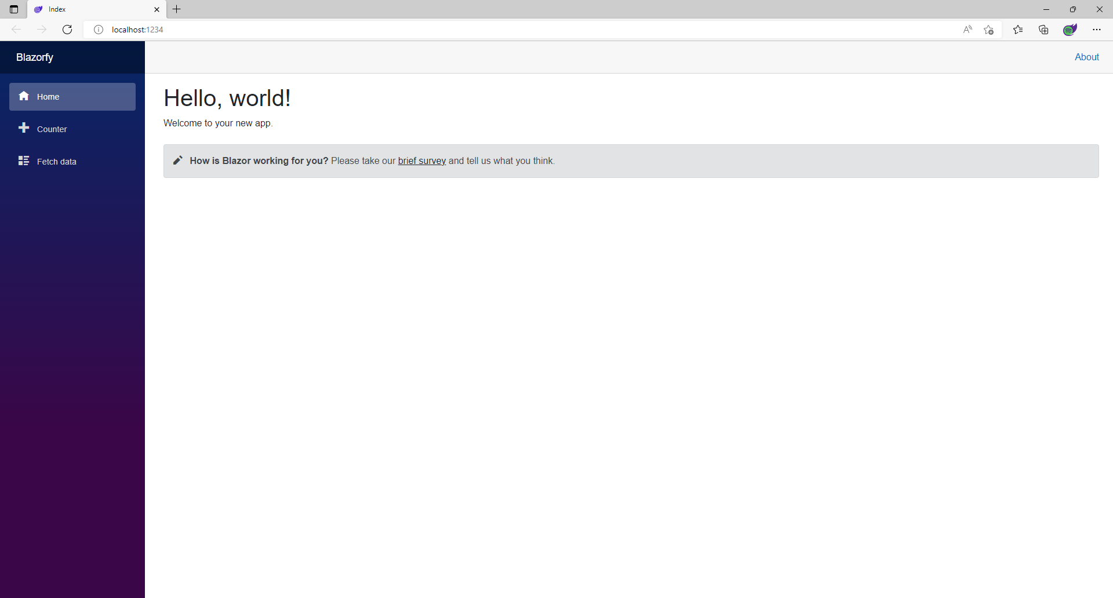

Make sure to keep the **Browser** open throughout the **Workshop**. However if you accidently close the **Browser** then you can return to **Visual Studio Code** and select the **Terminal** and then press **Ctrl+C** in **Windows** or **Command+C** on **Mac** on the **Keyboard** and then in the **Terminal** type **dotnet watch** again which should relaunch the **Browser** or if you close **Visual Studio Code** then you can just launch **Visual Studio Code** again then from the **Terminal** type **dotnet watch** to launch the **Browser**.

## Provider

The next we will start to write a **class** which represents something in **C#**, in this case will be **Provider**. This will allow you to group the main functionality to use **Spotify** in one place and create reusable code, this concept in software is known as *Don’t Repeat Yourself* or *DRY*.

Within **Visual Studio Code** from the **Explorer** move the **Cursor** over **Blazorfy** you will see a **New File…** option, if you select this and then type in the name as follows and then press **Enter**:

SpotifyProvider.cs

Once you press **Enter** after typing in the name you should see a blank *SpotifyProvider.cs* or you can select it from the **Explorer** in **Visual Studio Code** so you can see it as follows:

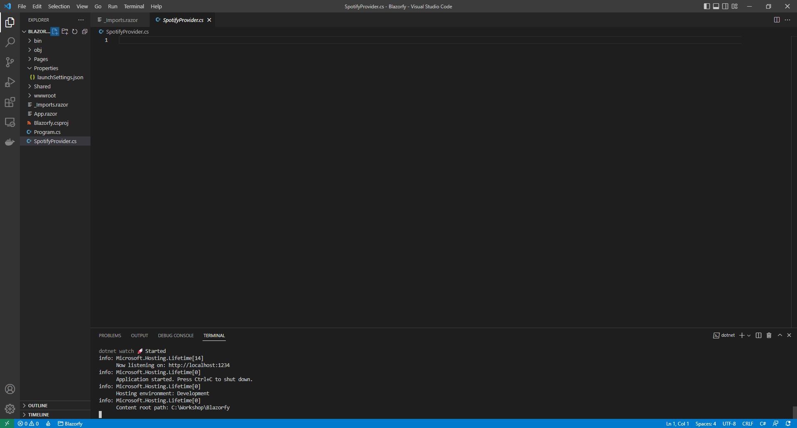

Should you make any mistakes with the **C#** in this **Workshop** then you will see **Errors** in the **Terminal** when you **Save** any changes. So if you see any **Errors** double check you haven’t missed anything, the key thing to remember is balance, you will be using a lot of curly braces that open like so **{** but will always have a counterpart of **}** this also applies to square brackets that will have both **[** and **]** and rounded brackets of **(** and **)** so it is a good idea to check if these are balanced, if you see any double-quotes or **"** then you should always expect to see another **"** nearby. Where you see any semi colons or **;** remember to include them, sometimes the smallest mistake that is easy to fix makes it work once corrected!

Should you make any mistakes with the **HTML** or **Razor** these may be harder to spot and may just not look correct in the **Browser** so make sure any angled brackets you see should open with **<** then you should

expect to see **>** nearby although you might see one on their own in **C#** but for **C#** that’s okay!

**Errors** will give you an idea of where to look for the mistake, they will often give a line number which you can check against the value shown at the bottom of **Visual Studio Code** you can always **Copy** and **Paste** any code in the **Workshop** but read through what you copied to see if you understand what it is doing!

## Namespaces

While still in **Visual Studio Code** at the top of *SpotifyProvider.cs* from the **Explorer** type in the following:

using Blazored.LocalStorage;

using Microsoft.AspNetCore.Components;

using Spotify.NetStandard.Client;

using Spotify.NetStandard.Client.Authentication;

using Spotify.NetStandard.Client.Interfaces;

using Spotify.NetStandard.Requests;

using Spotify.NetStandard.Responses;

namespace Blazorfy;

// Provider Class

**C#** has **namespaces** that group together related functionality and you can use existing functionality by including them at the top of a **class** with **using** and in this case they are for the **Packages** that were added for *Blazored.LocalStorage* and *Spotify.NetStandard*along with one that is needed from **.NET**.

Also please check these have been typed in correctly or you can **Copy** and **Paste** as in **C#** casing matters, for example *spotify.netstandard.client* is wrong but *Spotify.NetStandard.Client* is correct.

There is also a **namespace** of **Blazorfy** which will help group together the objects for the **Workshop** and finally there is a **Comment** which is anything with **//** in front of it below such as **// Provider Class** below which the **class** will be defined in the next part of the **Workshop**.

If you need to format any **Code** you have **Copy** and **Pasted** in **Visual Studio Code** you can do so with **Shift+Alt+F** on **Windows** or **Shift+Option+F** on **Mac** or right-click in any file and select **Format Document**.

## Class

While in **Visual Studio Code** for *SpotifyProvider.cs* below the **Comment** of **// Provider Class** type in the following which will define the structure of **class** for the **Provider** with **Comments** to help you put things in the right place later in the **Workshop**:

public class SpotifyProvider

{

// Constants

// Members

// Private Methods

// Constructor

// Property

// Login Method

// Logout Method

// Is Logged In Method

// Handle Code Method

// User Method

// List Method

// Search Method

}

This **class** will be populated with the functionality for the **Provider** and will be used throughout the **Workshop** and can use the **Comments** so you know where you need to put things in the **class**.

You will be guided through each part step-by-step but the next part will be to add **class** so it can be used later in the next part of the **Workshop**.

## Program

In **Visual Studio Code** you will also see a *Program.cs* file in the **Explorer** that when selected should be similar to the following:

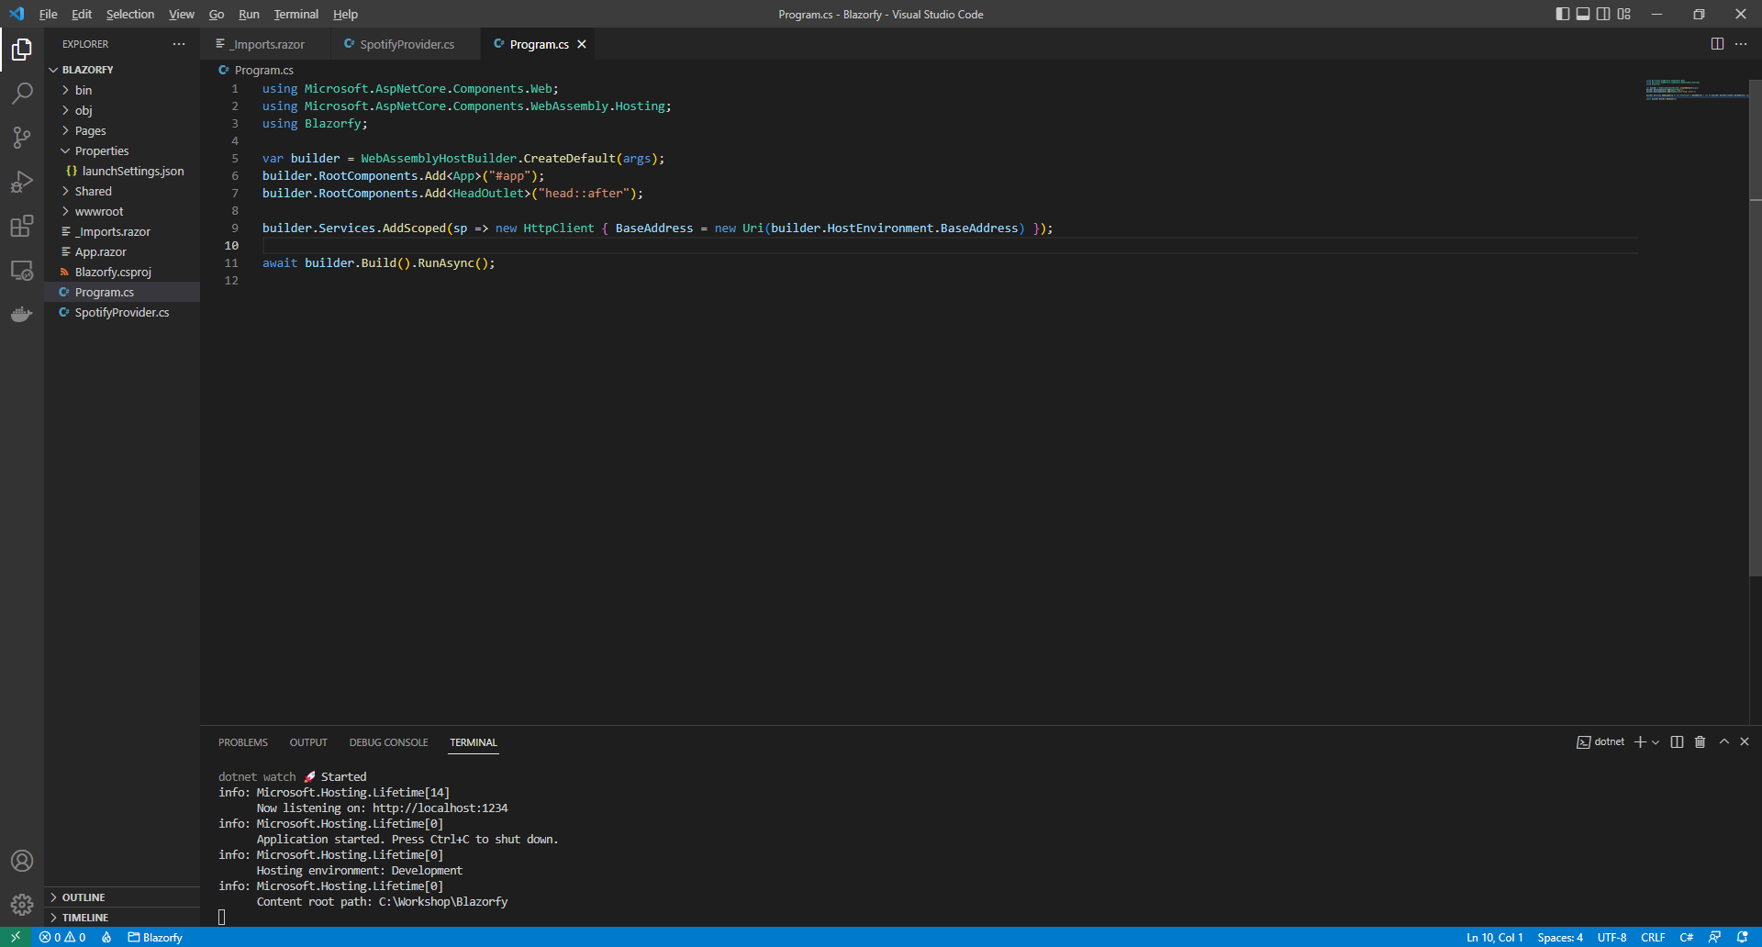

Within *Program.cs* add **using** for *Blazored.LocalStorage* below **using Blazorfy;** by typing in the following:

using Blazored.LocalStorage;

Then while still in *Program.cs* and above the **await builder.Build().RunAsync();** type in the following:

builder.Services.AddBlazoredLocalStorage();

builder.Services.AddScoped<SpotifyProvider>();

You can then go to the **Menu** in **Visual Studio Code** and select **File** and then **Save All**, you may see in the **Terminal** a message saying **Do you want to restart your app - Yes (y) / No (n) / Always (a) / Never (v)?** you can select the **Terminal** then type **y** for **Yes** or **a** for **Always** to keep what you have done so far.

This will add what is needed by *Blazored.LocalStorage*and will also add the **class** of **SpotifyProvider** to be available to the **Dependency Injection** system used in **Blazor. Dependency Injection** allows specific functionality to be provided to an application to anywhere that needs it. In **C#** an **Instance** of a **class** is needed in order for it to be used but by adding the **class** this way we can get **Dependency Injection** to do it for us, if you want to know more about it this concept then you can read up on it after you have completed the **Workshop**.

At this point you should have modified the files of *launchSettings.json* and *Program.cs* along with creating a file called *SpotifyProvider.cs* you can go over the previous steps now to double-check you’ve done everything correctly then proceed to implementing **Authentication** in the next section of the **Workshop**.

# Authentication

## Account

In this part of the **Workshop** you will learn how to **Login** to **Spotify** and also **Logout**. Youcan **Create** your own **Account** on **Spotify** or use an existing **Account** by launching another **Browser** and go to the **Spotify for Developers** website at [developer.spotify.com](https://developer.spotify.com/).

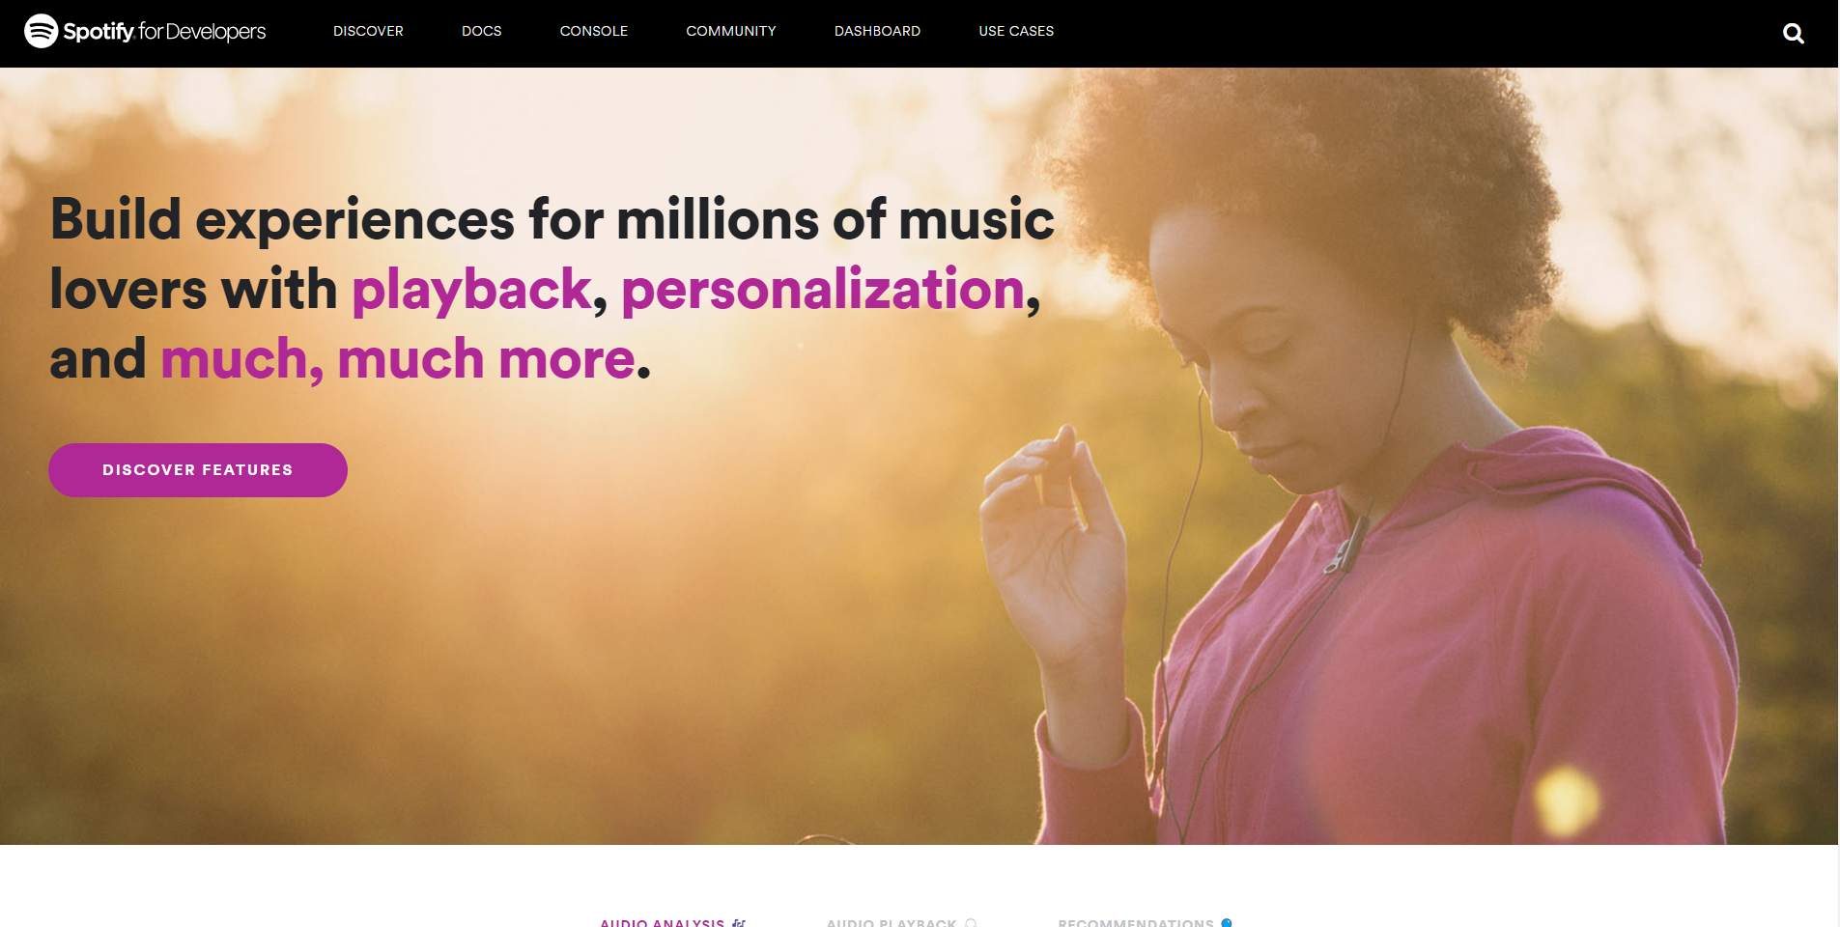

Once on the website for **Spotify for Developers** selection option for **Dashboard** as follows:

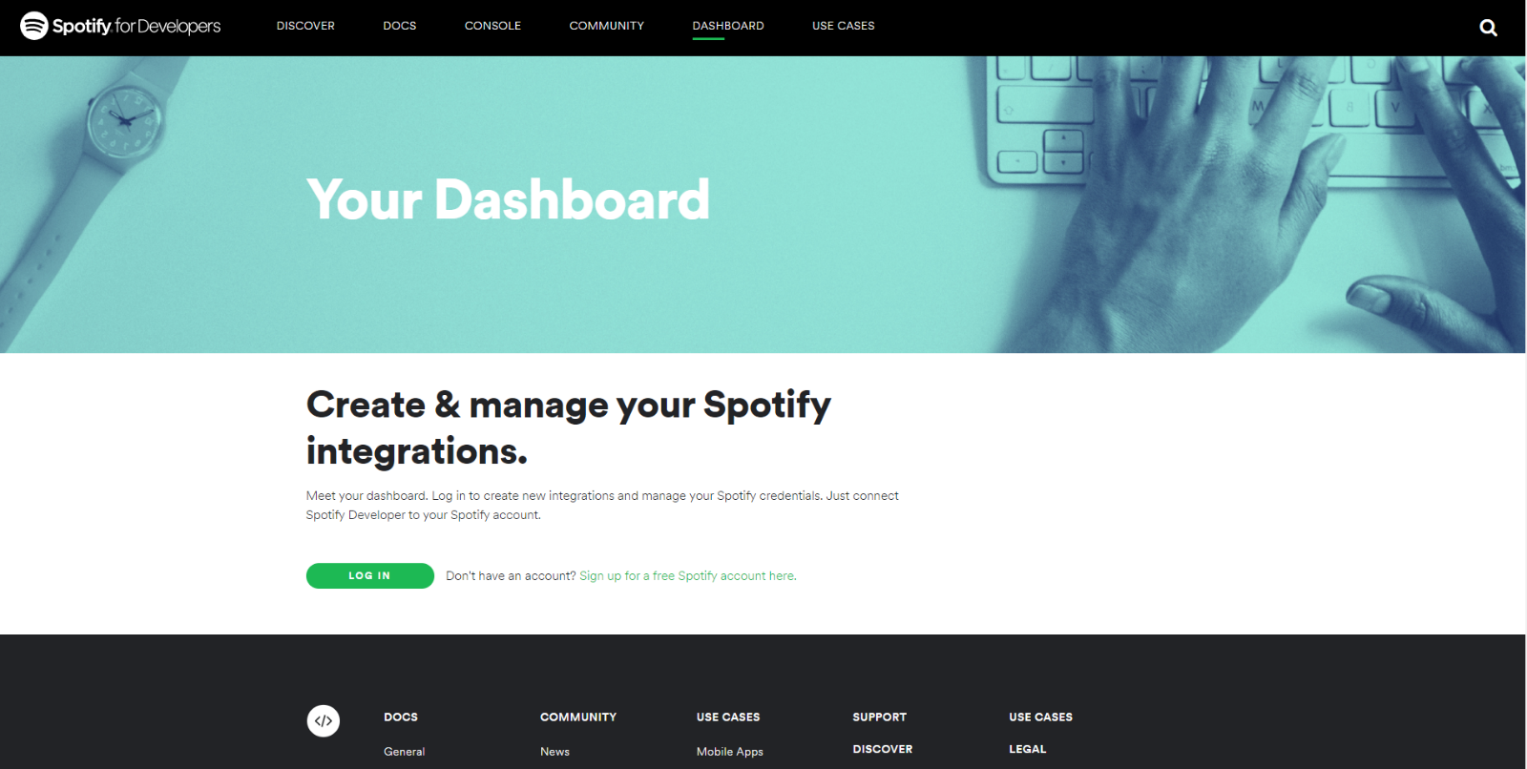

The **Dashboard** is where you can **Create** and **Manage** integrations that use **Spotify**.

If you have an existing **Account** for **Spotify** select **Log In** and then type in your **Email address or username** and **Password** on the following screen and then select **Log In**:

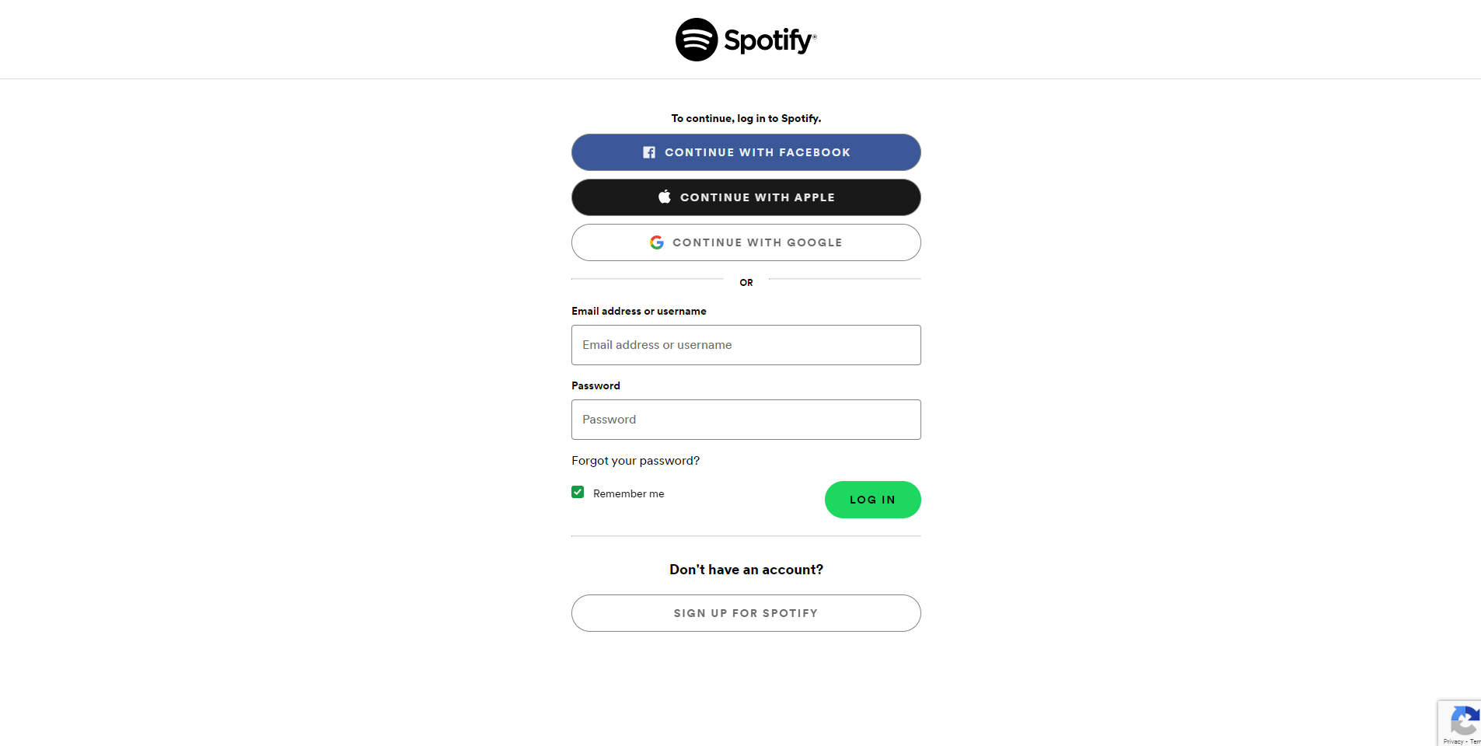

If don’t have an existing **Account** for **Spotify** then select **Sign-up for a free Spotify account here** and then select **Sign up for Spotify** and then fill in the details on the following page:

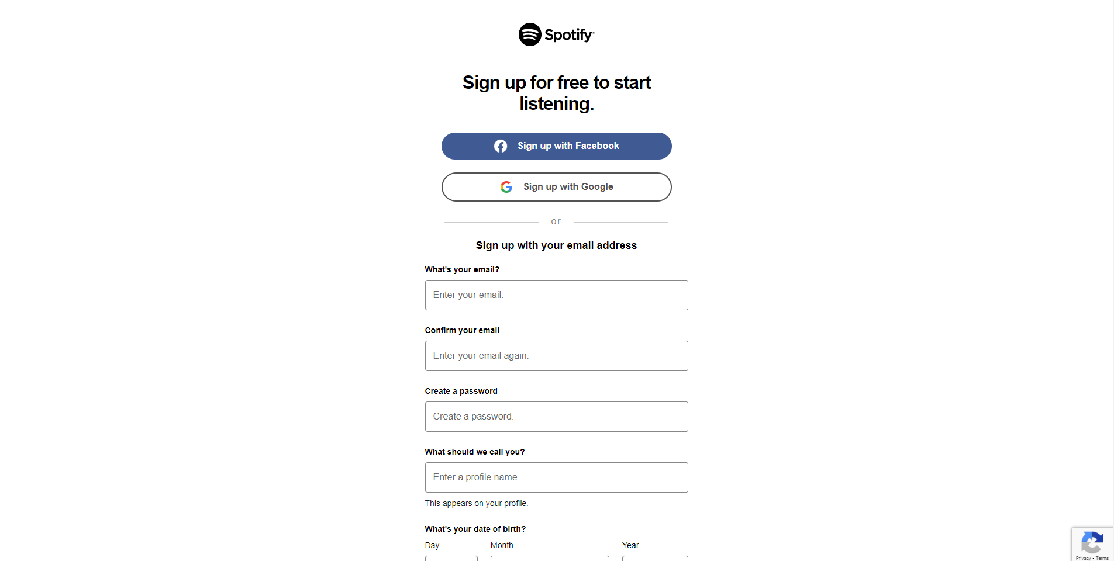

Once the **Account** has been created or if have logged into an existing **Account** for **Spotify** then you should get the following option to **Accept** the Terms and Conditions, just read through this then select the **I accept the Spotify Developer Terms of Service** and then select **Accept the** **Terms** as follows:

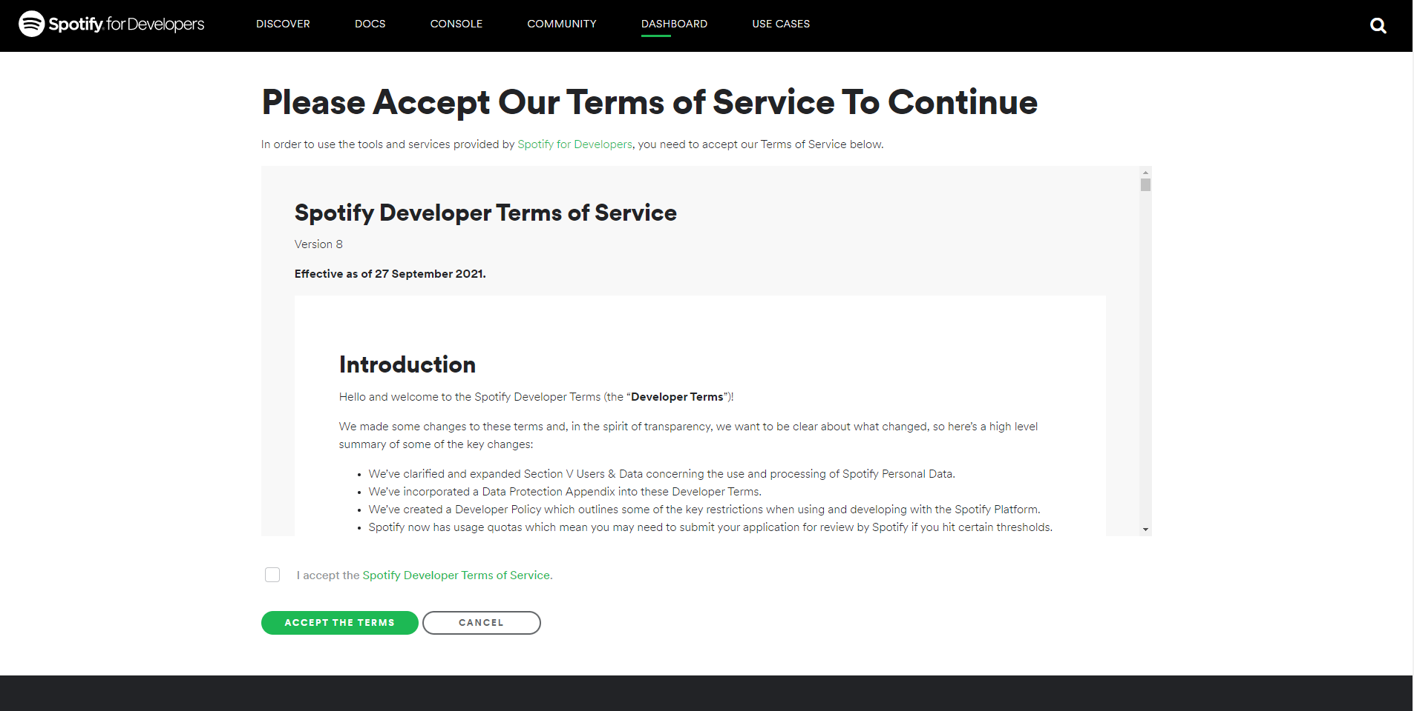

Once you have selected **Accept the Terms** then you will be taken to the **Dashboard** as follows:

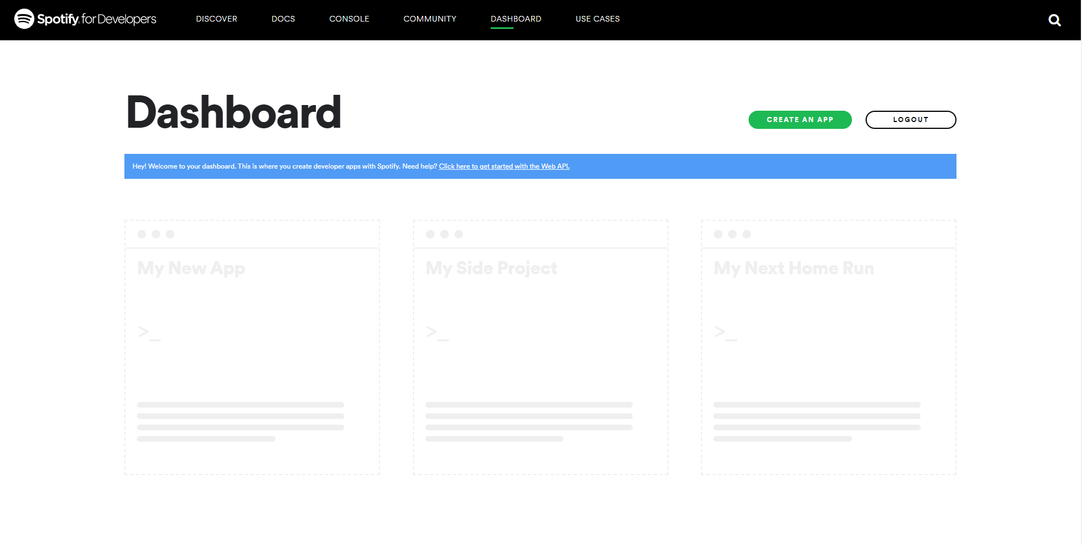

Once in the **Dashboard** you can then select **Create an App** and then enter the **App Name** as *Blazorfy* and the **App Description** as *Blazorfy* and then after reading the **Developer Terms of Service** and **Branding Guidelines** select the option for **I understand and agree with Spotify’s Developer Terms of Service and Branding Guidelines** then select the **Create** option.

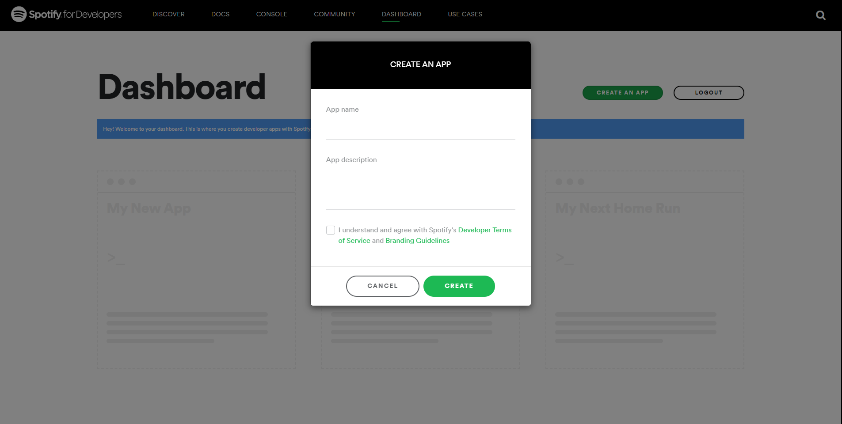

Once the **App** has been created you will see the following **Overview** where you will need to **Copy** and **Paste** the **Client ID** to somewhere so it can used later in the **Workshop** as follows:

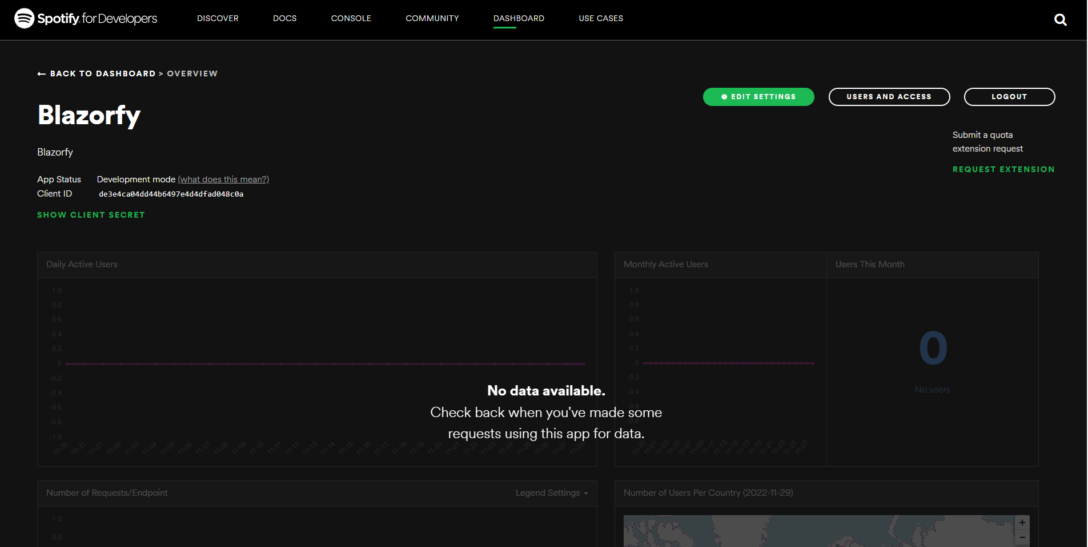

Then select the **Edit Settings** from the **Overview** for the **App** and then within **Edit Settings** in the section for **Redirect URIs** and in the box with *https://example.com/callback* type in **https://localhost:4321/** and select **Add** and then in the box with *https://example.com/callback* type in **http://localhost:1234/** and then select **Add** from the following screen:

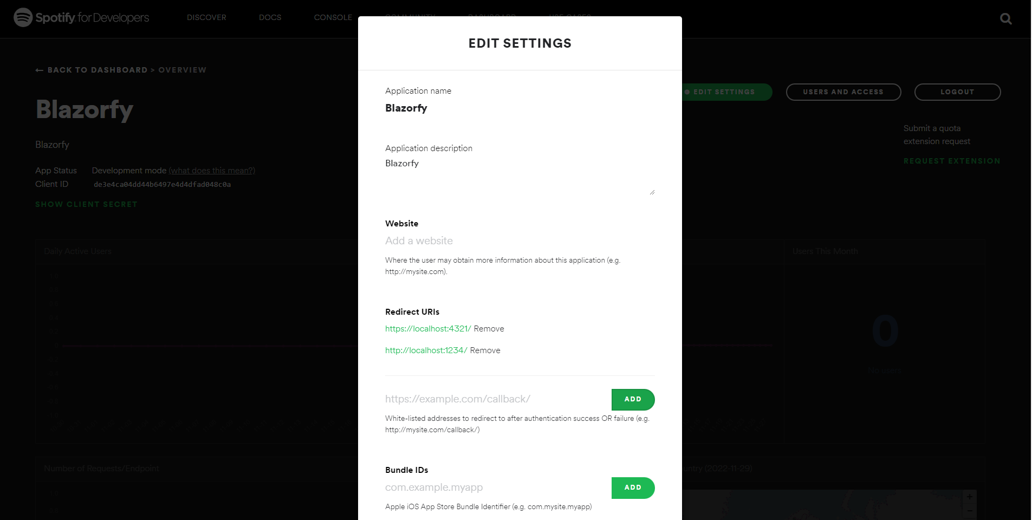

Then from the **Overview** for the **App** select **Users** **and Access** as follows:

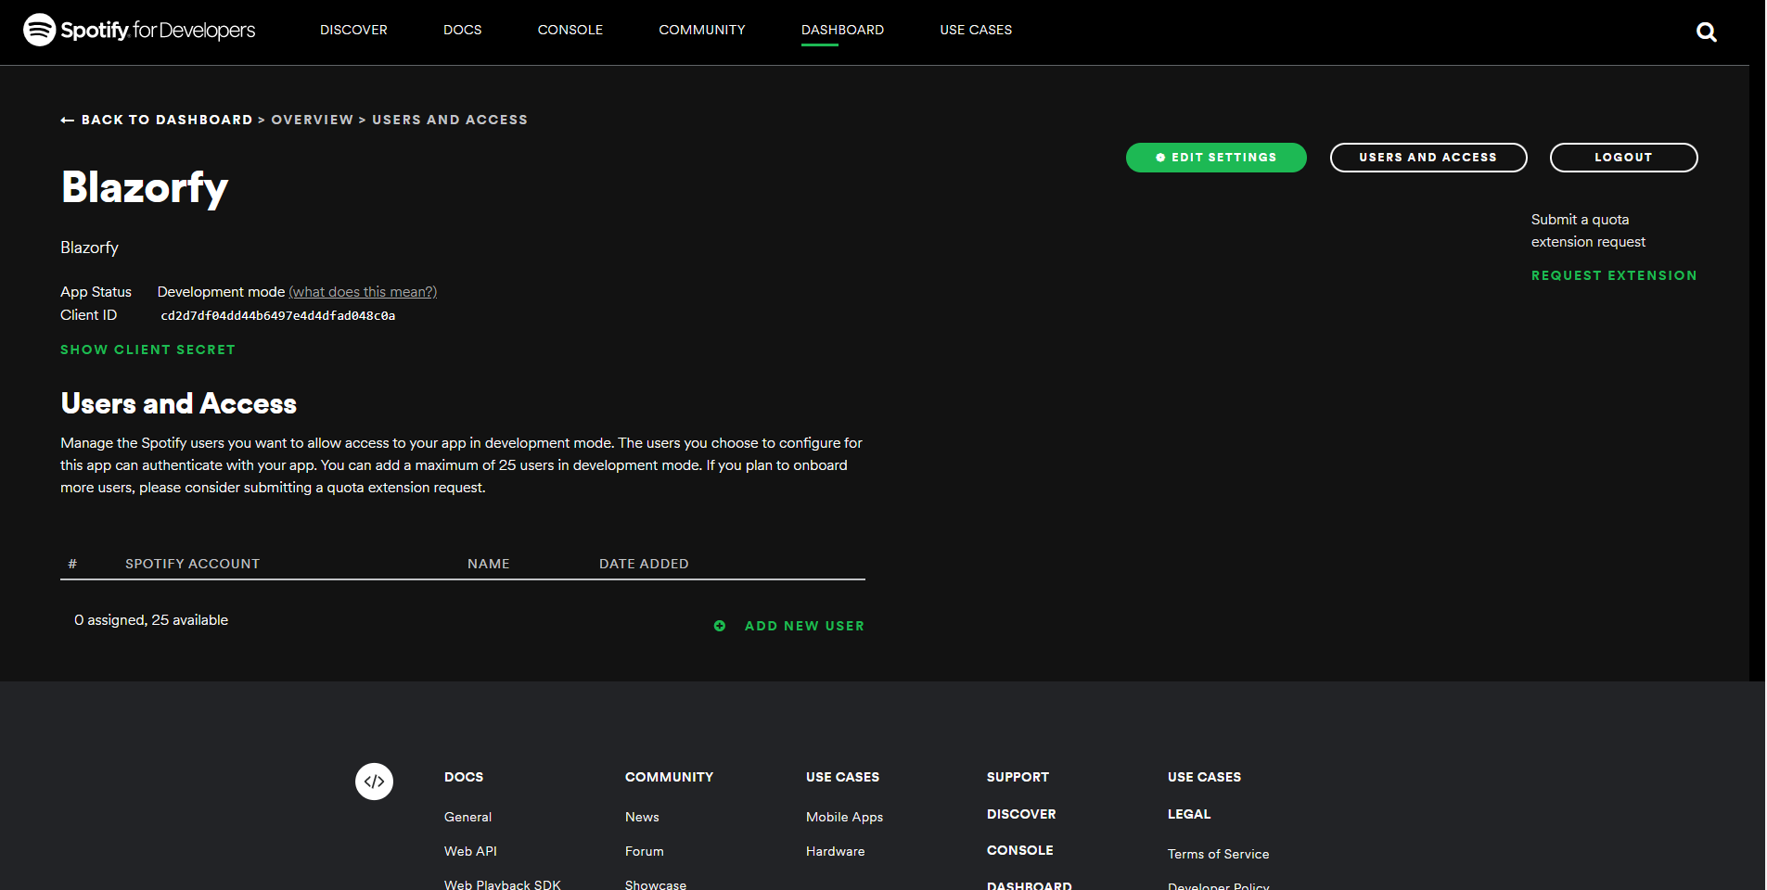

Then from page for **Users and Access** select the option for **Add New User** and then type in the **Name** and **Spotify Account (email address)** for your **Account** on **Spotify** and then select Add as follows:

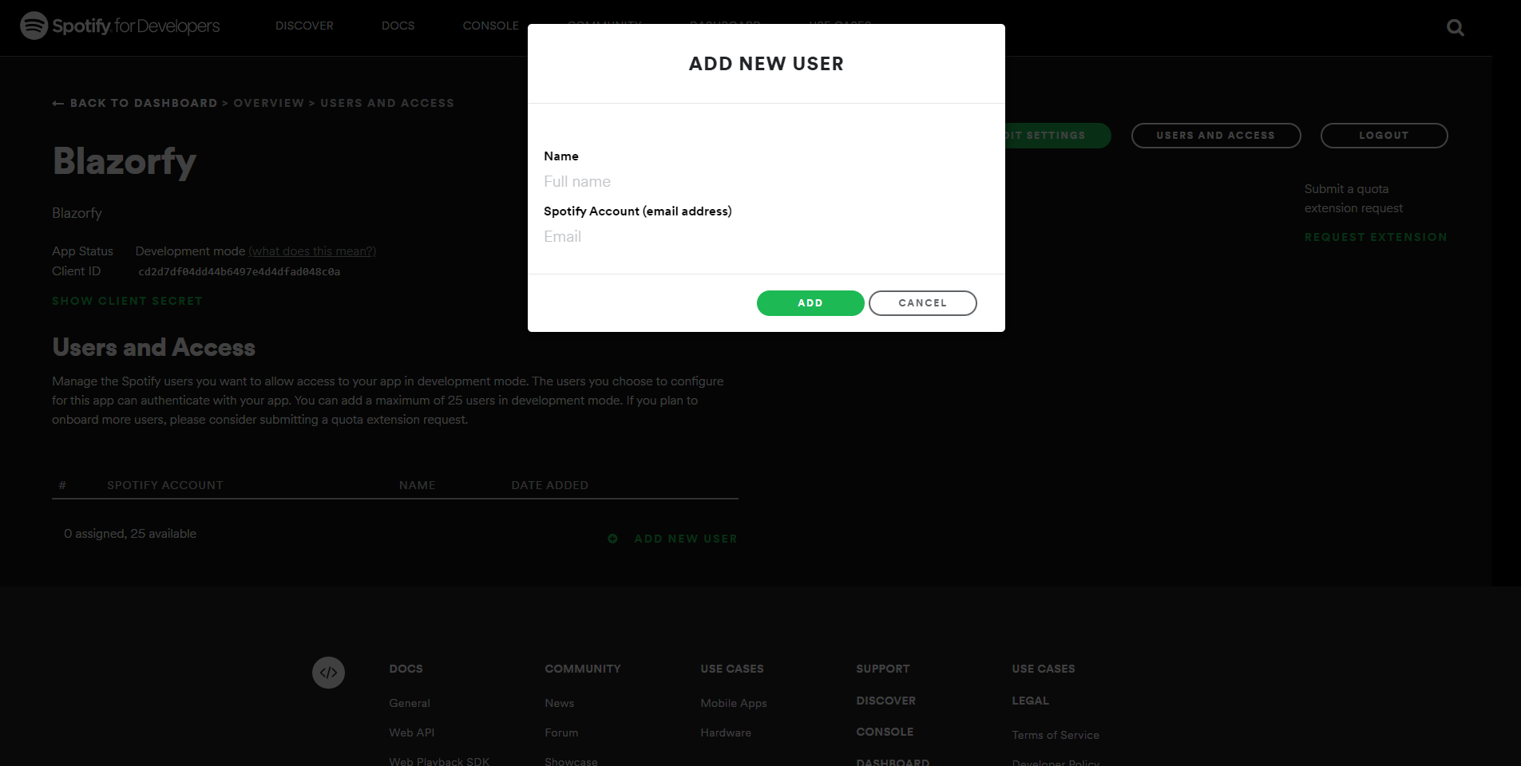

Once your **Account** shows up in the **Users and Access** and you have the **Client Id** then you can proceed with the rest of the **Workshop**.

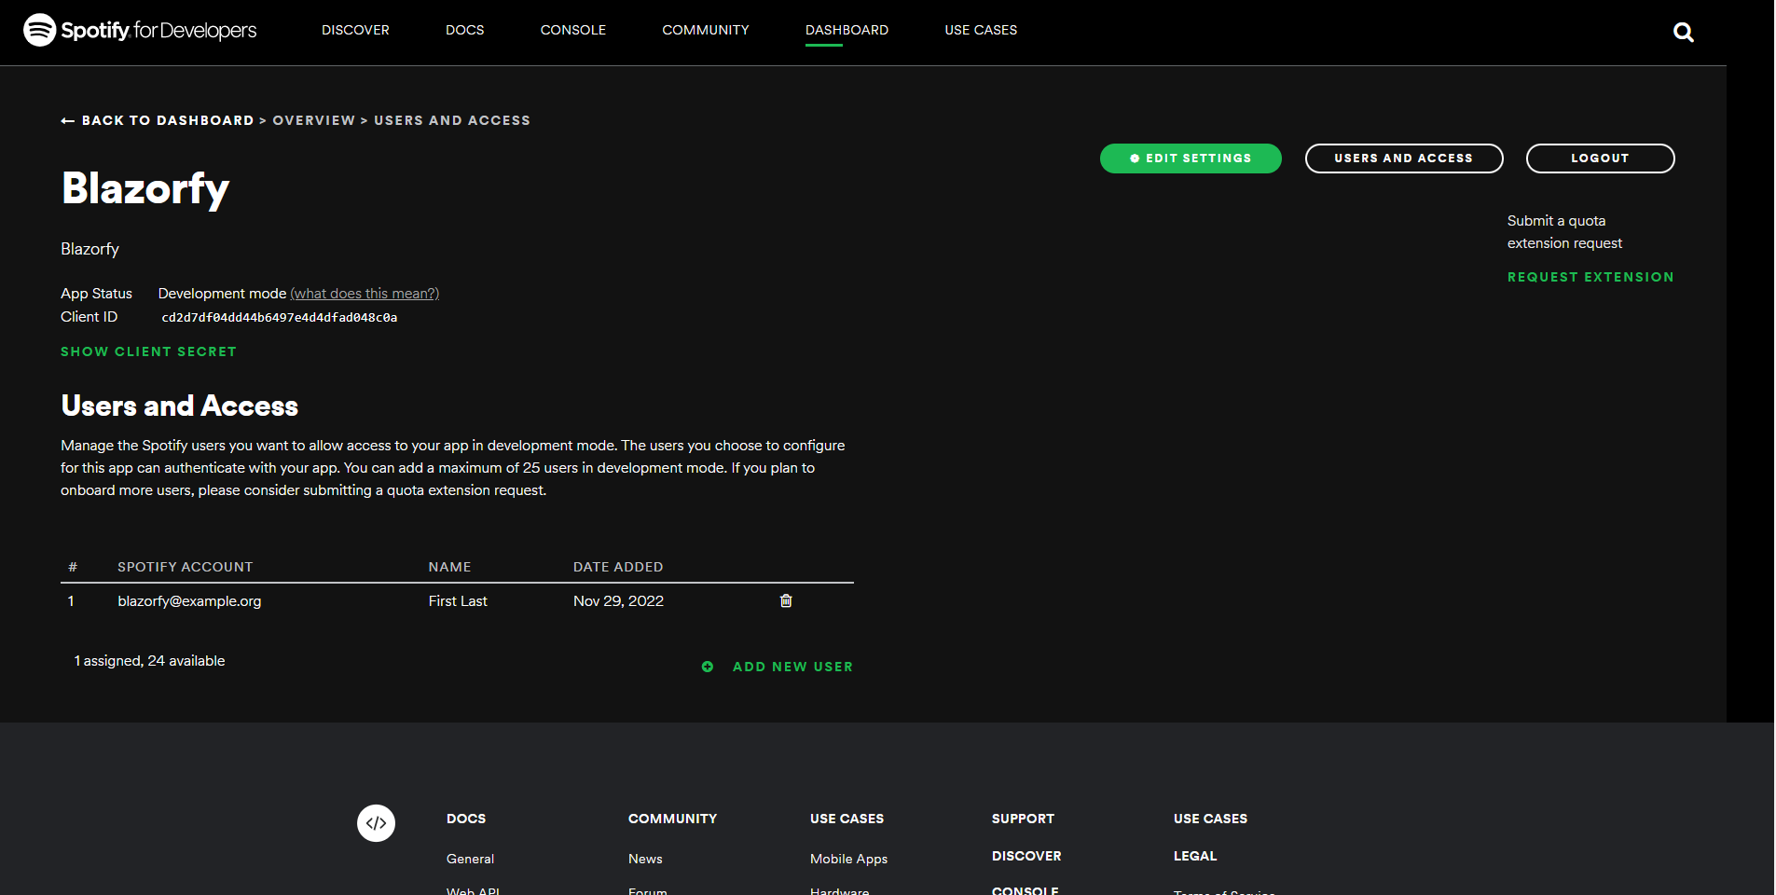

## Constants

Back in **Visual Studio Code** from the **Explorer** select *SpotifyProvider.cs* which should have the following contents from the **Start** of the **Workshop**:

using Blazored.LocalStorage;

using Microsoft.AspNetCore.Components;

using Spotify.NetStandard.Client;

using Spotify.NetStandard.Client.Authentication;

using Spotify.NetStandard.Client.Interfaces;

using Spotify.NetStandard.Requests;

using Spotify.NetStandard.Responses;

namespace Blazorfy;

// Provider Class

public class SpotifyProvider

{

// Constants

// Members

// Private Methods

// Constructor

// Property

// Login Method

// Logout Method

// Is Logged In Method

// Handle Code Method

// User Method

// List Method

// Search Method

}

Then in **Visual Studio Code** within *SpotifyProvider.cs* you will define **Constants** with **const** such as the **client_id** as a **string** for text and how many and the maximum number of items that will be retrieved later as an **int** for numbers. These will only be used inside the **class** so are declared with **private**.

Below the **Comment** of **// Constants** on type the following, replacing **clientid** with your **Client Id**

private const string client_id = "clientid";

private const int total = 50;

private const int max = 100;

## Members

While still in *SpotifyProvider.cs* in **Visual Studio Code** you will define some **Members** by typing below the **Comment** of **// Members** the following:

private readonly NavigationManager _navigation;

private readonly ILocalStorageService _storage;

private readonly ISpotifyApi _api;

private readonly Uri _redirectUri;

private AccessToken? _token;

**Members** represent values within the **class** and these are used within the **class** so are marked **private** with the first four being set in the **Constructor** later so can use **readonly** to not set them again there.

**NavigationManager** is needed to both get the current address or **URI** of the page and to redirect to a particular page or **URI** when needed.

**ILocalStorageService** is from the **Package** of *Blazored.LocalStorage*and is an **Interface** which allows functionality to be exposed from a **class** but be abstracted so the functionality could change but as long as that stays the same anything using the **Interface** will still work, with this functionality being the ability to load or save information needed for the **Workshop** in the **Browser**.

**ISpotifyApi** is also an **Interface** and is from the **Package** of *Spotify.NetStandard* which will be used to perform the functionality needed from **Spotify** which will also use the **Uri** which will be passed to **Spotify** and an **AccessToken** is defined which will be returned from **Spotify** when have successfully logged in.

## Methods

While still in *SpotifyProvider.cs* in **Visual Studio Code** you will define some **Methods** by typing below the **Comment** of **// Private Methods** the following:

private Uri GetCurrentUri() =>

_navigation.ToAbsoluteUri(_navigation.Uri);

private async Task SetTokenAsync(AccessToken? token) =>

await _storage.SetItemAsync(nameof(_token), token);

These **Methods** will only be used within the class itself so again are declared with **private**. The first one will help get the current address of the page of the **Browser** and uses the **NavigationManager** that was declared previously. The second **Method** will use the **ILocalStorageService** to store the **AccessToken** from **Spotify**. These **Methods** use the Arrow Syntax with the **=>** for an Expression Bodywhich is useful when they only have one line to save space.

## Constructor

While still in *SpotifyProvider.cs* in **Visual Studio Code** you will define the **Constructor** by typing below the **Comment** of **// Constructor** the following:

public SpotifyProvider(

HttpClient client,

NavigationManager navigation,

ILocalStorageService storage)

{

_storage = storage;

_navigation = navigation;

_redirectUri = new Uri(GetCurrentUri().GetLeftPart(UriPartial.Path));

_api = SpotifyClientFactory.CreateSpotifyClient(client, client_id).Api;

}

**Constructor** sets up a **class** as well as allowing any other **class** or **interface** to be provided using **Dependency Injection** which in this case includes **HttpClient** which will provide the ability to communicate that is used in the **Method** of **SpotifyClientFactory.CreateSpotifyClient** along with the **client_id**. Both the **NavigationManager** and **ILocalStorageService** are also provided and

the redirection **Uri** is also set by using the **Method** of **GetCurrentUri**.

## Property

While still in *SpotifyProvider.cs* in **Visual Studio Code** you will define a **Property** by typing below the **Comment** of **// Property** the following:

public bool IsLoggedIn =>

_token != null;

A **Property** is the best way to expose values outside of a **class** in **C#** which is also done by using **public** so that this value is available to anywhere else that uses this **class**. This **Property** will be used to indicate if the **Account** has been logged or not with a **bool** which is a **true** or **false** value by checking the **AccessToken** which also had a question mark or **?** which means it can have **null** as the value which is what is being checked by using **!=** which means not equal to, so when the value is **null** the **Property** will be **false** and if the value is not **null** the **Property** will be **true**.

You can then go to the **Menu** in **Visual Studio Code** and select **File** and then **Save All** you may see in the **Terminal** a message saying **Do you want to restart your app - Yes (y) / No (n) / Always (a) / Never (v)?** you can select the **Terminal** then type **y** for **Yes** or **a** for **Always** to keep what you have done so far.

## Login

Next within *SpotifyProvider.cs* in **Visual Studio Code** you will define a **Method** by typing below the **Comment** of **// Login Method** the following:

public async Task LoginAsync()

{

var responseUri = _api.GetAuthorisationCodeAuthUri(

_redirectUri,

nameof(SpotifyProvider),

Scope.None,

out string codeVerifier);

await _storage.SetItemAsync(nameof(codeVerifier), codeVerifier);

if (responseUri != null)

_navigation.NavigateTo(responseUri.ToString());

}

There’s a few things going on in this **Method** the first thing to notice is it has **public** which allows it to be used outside the **class** it also has **async** and **Task** as this **Method** performs some functionality asynchronously which means something will happen then the result of this action will be waited for with **await** and then the application can continue.

The first thing the **Method** does is get the **Uri** needed to **Authenticate** with **Spotify** and the **Uri** to redirect back to once this is done is provided along with a **state** using **nameof(SpotifyProvider)** and a **Scope** which controls what access to **Account** specific functionalityis needed but in this case there’s nothing of that nature required so *None* is used. Another value is also output using the **out** which is a **Code Verifier** which is needed to complete the **Authentication** process.

The next thing the **Method** does is to store the **Code Verifier** in the **Storage** of the **Browser** and it is this **Method** that is asynchronous then if there was a **Uri** returned from the first part of the **Method** then finally the **NavigationManager** is used to redirect to it on **Spotify**.

## Logout

Then within *SpotifyProvider.cs* in **Visual Studio Code** you will define another **Method** by typing below the **Comment** of **// Logout Method** the following:

public async Task LogoutAsync()

{

await SetTokenAsync(_token = null);

_navigation.NavigateTo(_redirectUri.ToString(), true);

}

This will be used to log out of an **Account** and it does this by setting the **AccessToken** to **null** and then storing that using the **Method** of **SetTokenAsync** then finally it will use **NavigationManager** to redirect to the **Uri** for redirection and will force the page to refresh when doing so.

## Logged In

Then within *SpotifyProvider.cs* in **Visual Studio Code** you will define the next **Method** by typing below the **Comment** of **// Is Logged In Method** the following:

public async Task<bool> IsLoggedInAsync()

{

_token ??= await _storage.GetItemAsync<AccessToken>(nameof(_token));

if (_token != null)

{

if (_token.Expiration < DateTime.UtcNow)

{

await LogoutAsync();

}

else

{

_api.Client.SetToken(_token);

}

return IsLoggedIn;

}

return false;

}

This **Method** checks and does a few things so let’s break it down, overall it will **return** a value that is either **true** to indicate the **Account** is logged in or **false** if it is not.

The first thing it does is use the **ILocalStorageService** to set the **AccessToken** you’ll also notice the use of the **??=** which is known as the null-coalescing assignment **Operator**, but in plain English it means it will only perform the action to get the **AccessToken** if it has not already been set to something, that is it will still be **null**.

The **AccessToken** is then checked to see **if** it is not **null** by using the **!=** or not equal to **Operator** and if this is **false** the next part will be skipped and the **return** from the **Method** will be **false**.

If the **AccessToken** is not **null** was **true** then next thing is to check if the **AccessToken** has expired by comparing the **Expiration** against the current date and time in *UTC* and if expired we logout using **LogoutAsync** or if it has not expired we will to use a **Method** in the **Client** for **ISpotifyApi** to set the **AccessToken**.

Then we can just **return** the **Property** of **IsLoggedIn** to indicate the **Account** is logged in.

## Handle Code

Next within *SpotifyProvider.cs* in **Visual Studio Code** you will define the next **Method** by typing below the **Comment** of **// Handle Code Method** the following:

public async Task<bool> HandleCodeAsync(string? code)

{

if (code != null)

{

string codeVerifier =

await _storage.GetItemAsync<string>(nameof(codeVerifier));

_token = await _api.GetAuthorisationCodeAuthTokenAsync(

GetCurrentUri(),

_redirectUri,

nameof(SpotifyProvider),

codeVerifier);

await SetTokenAsync(_token);

_navigation.NavigateTo(_redirectUri.ToString());

}

return await IsLoggedInAsync();

}

This **Method** will be used as part of the process of logging into **Account** when the process is competed in the **Browser** for **Spotify** it will redirect back to the redirection **Uri** that was specified along with returning a **Code** which will be handled with this **Method**.

The first thing is that the value passed in is checked to see if it is not **null** with the **!=** or not equal to **Operator** and if it does have a value then it can then get the **Code Verifier** from the **Storage** in the **Browser** then this is used with the **Method** of **GetAuthorisationCodeAuthTokenAsync** in **ISpotifyApi**. The response **Uri** is needed which will be used to get the **Code** that was passed along from **Spotify** and the same **State** is used as before and the **Code Verifier** is also provided.

The next thing is the **Method** for **SetTokenAsync** is called to store the **AccessToken** and then the **NavigationManager** will be used to reload the page to complete the logging in process, should no **Code** be provided then the result of the **Method** of **IsLoggedInAsync** will be used instead.

## User

Finally within *SpotifyProvider.cs* in **Visual Studio Code** you will define the **Method** to get the **User** for the **Account** by typing below the **Comment** of **// User Method** the following:

public async Task<PrivateUser> GetUserAsync() =>

await _api.GetUserProfileAsync();

This **Method** uses the Arrow Syntax with the **=>** for an Expression Bodywhich is useful when a **Method** only has one line to save space and will get the **User** for the Accountwhich will be used in a **Component** which will be created in the next part of the **Workshop**.

## Component

Within **Visual Studio Code** from the **Explorer** and move the **Cursor** over the **Blazorfy** you will see a **New Folder…** option next to the **New File…** option if you select **New Folder…** and then type in the name as follows then press **Enter**:

Components

With the **Folder** for **Components** selected you should then select the **New File…** option and type in the name as follows then press **Enter**:

LoginItem.razor

This will form the basis of a **Razor Component** which is also known as a **Blazor** **Component** in **Blazor** or just **Component** in the **Workshop** and for now you should have a blank **Component** as follows:

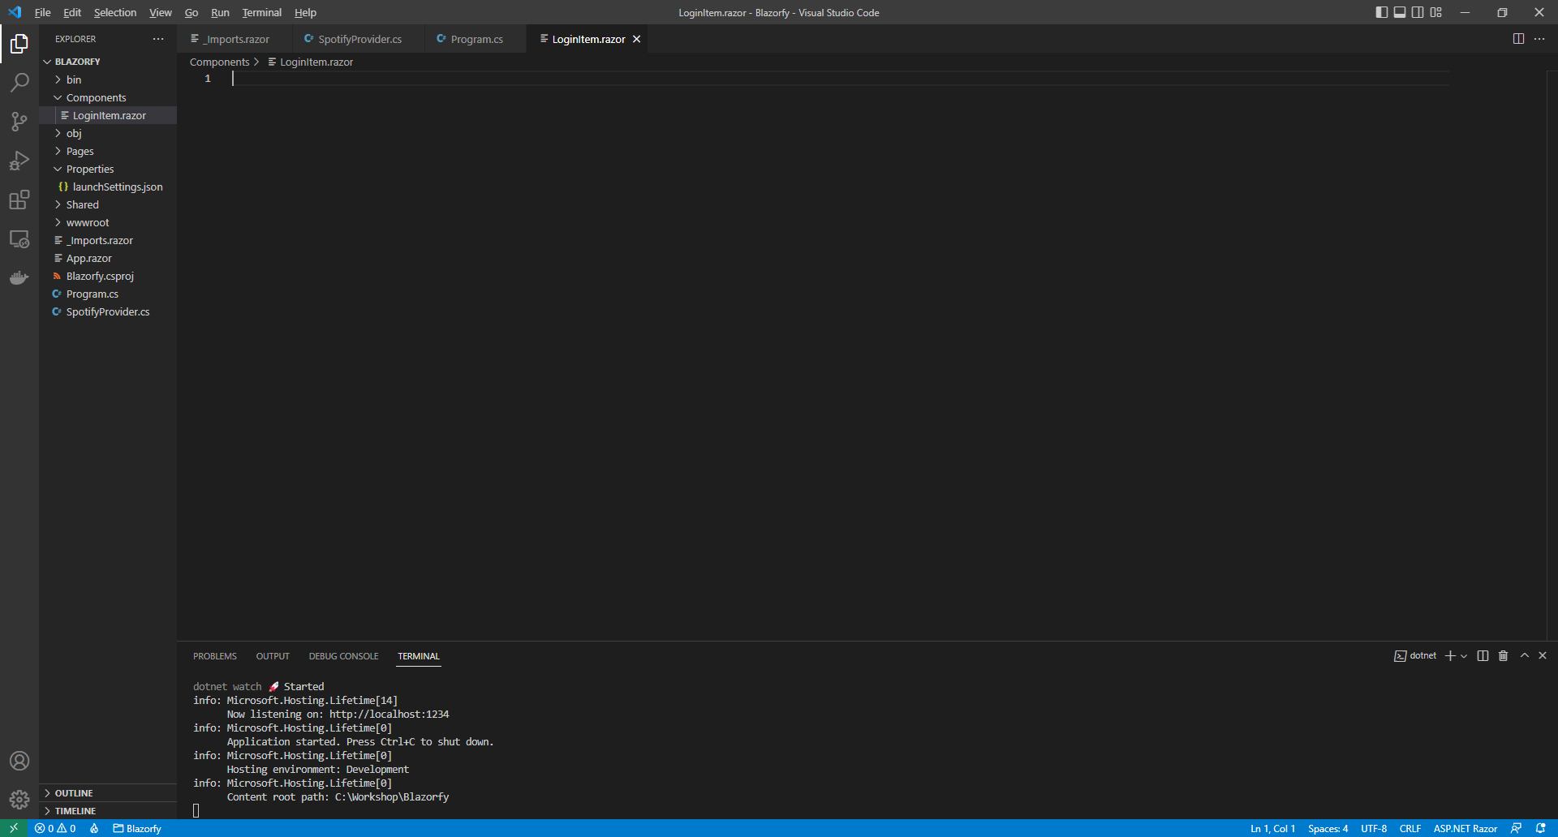

**Components** allow you to reuse or define either some functionality or some **Razor** and **HTML** to create a piece or **Component** of an application that you can see in **Blazor**.

Within *LoginItem.razor* in **Visual Studio Code** you can define the **Component** by typing in the following:

@namespace Blazorfy

@inject SpotifyProvider _provider;

@if (Value)

{

<button class="btn btn-danger" @onclick="_provider.LogoutAsync">Logout</button>

<span class="badge bg-primary">@Item?.DisplayName</span>

}

else

{

<button class="btn btn-success" @onclick="_provider.LoginAsync">Login</button>

}

@code

{

[Parameter]

public bool Value { get; set; }

public PrivateUser? Item { get; set; }

protected override async Task OnParametersSetAsync()

{

if (Value)

{

Item = await _provider.GetUserAsync();

}

}

}

The first part of the **Component** is the **namespace** for the application which is **Blazorfy** then the next part will provide the **Instance** of the **SpotifyProvider** using **Dependency Injection** with **inject**.

There’s a **Property** for **Value** which can be either **true** or **false** as it is a **bool** and will be used to indicate to the **Component** that the **Account** is logged in or not.

If the **Account** is logged in, which will be provided to the **Component**, then the **Property** for **Value** will be **true** the with the **DisplayName** of the currently logged in **Account** and a **button** to **Logout** will be displayed which will call the **Method** of **LoginAsync** from the **class**. Should the **Property** for **Value** be **false** then the option to **Login** will be displayed which will call the **Method** of **LogoutAsync**.

There’s also an additional **Property** for a **PrivateUser** which is for the user of the **Account** from **Spotify** then there is a special **Method** where the implementation of which has been overridden to provide our own denoted with **override** in this case it is for **OnParametersSetAsync** which is called when the **Properties** for the **Component** are set by **Blazor** and within this we get the details for the user of the **Account**.

You might be wondering why **Value** is used here rather than checking if the **Account** is logged in directly, well we can take advantage of the fact when a value is passed into a **Component** and that value changes it will cause the **Component** to be updated rather than having to write that functionality ourselves as **Blazor** will automatically output a **Component** again should the value passed into it change.

## Index

Next within **Visual Studio Code** from the **Explorer** for **Blazorfy** open **Pages** by selecting the **>** next to it and select **index.razor**, where you will see what is currently being displayed in the **Browser** as follows:

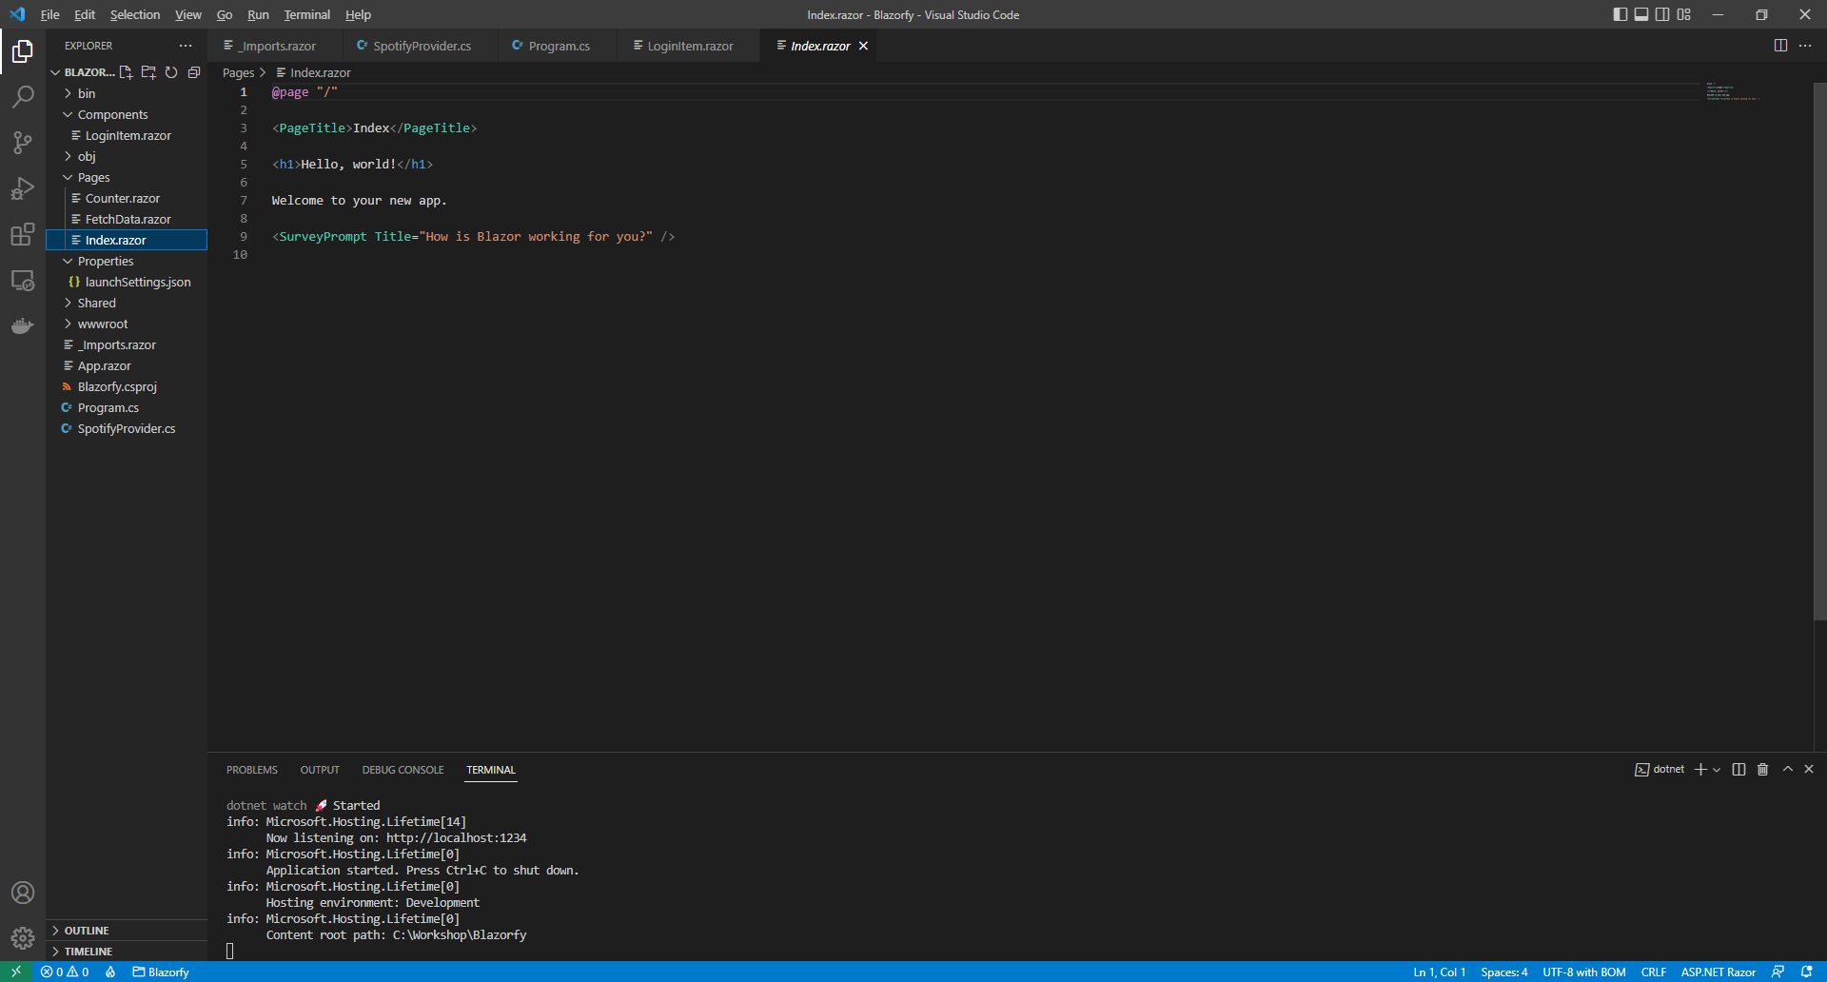

You will need to remove everything except the **@page "/"** at the top of the file so it appears as follows:

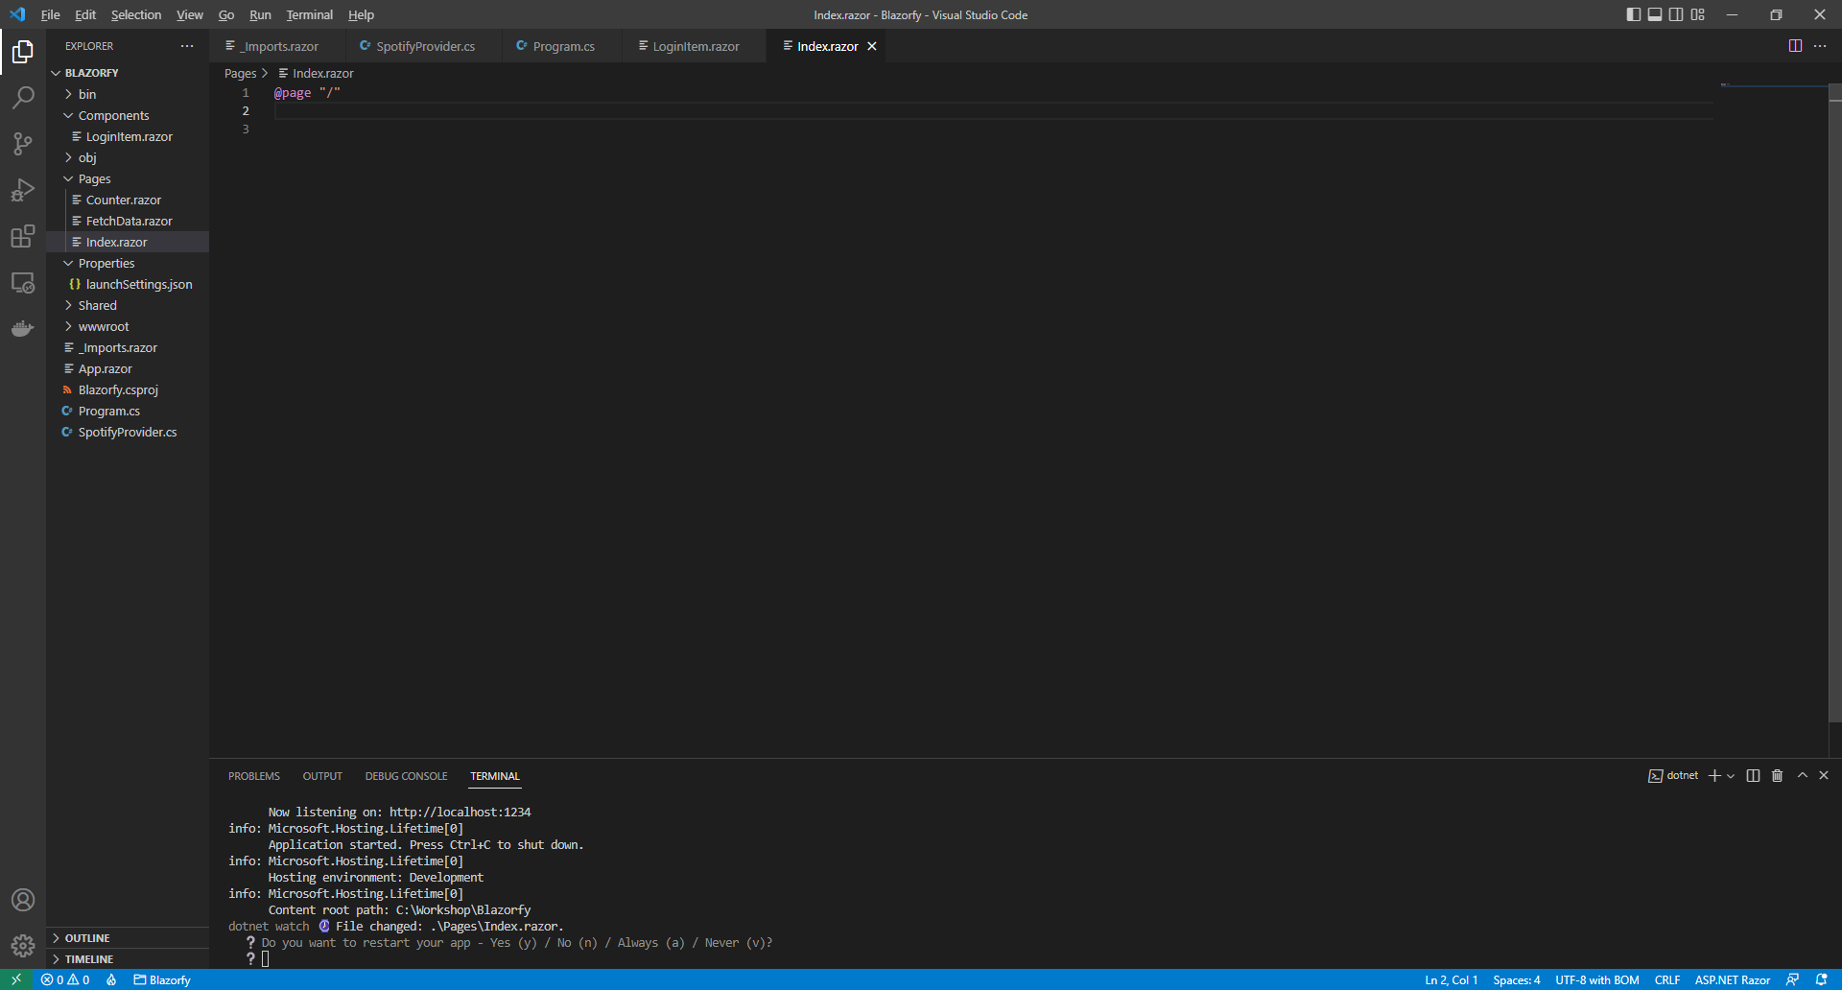

Within *Index.razor* in **Visual Studio Code** you can define the new **Page** by typing in below **@page "/"** the following which will also include some **Comments** to help you place some items later in the **Workshop**:

@inject SpotifyProvider _provider;

<**LoginItem** **Value**="@_provider.IsLoggedIn" />

@if (_provider.IsLoggedIn)

{

// Items Output

}

@code

{

[Parameter]

[SupplyParameterFromQuery]

public string? Code { get; set; } = null;

// Items Property

protected override async Task OnParametersSetAsync()

{

if (await _provider.HandleCodeAsync(Code))

{

// Items List

}

}

}

This **Page** now includes the same line to provide the **Instance** of the **SpotifyProvider** using **Dependency Injection** with **inject** as the **Component**. Then there is the **Component** with the **Value** being provided with the **Property** for **IsLoggedIn** from the **class**. This is then followed by the same **Property** being used in an **if** which will be used later in the **Workshop** to display some items.

There is also **Code** for the **Page** which includes a **Property** for the **Code** which will be provided to this page by **Spotify** after completing the login process this is set to be a **Parameter** with an **Attribute** which is within square brackets of **[** and **]** so that **Blazor** expects this to be set along with another **Attribute** to tell **Blazor** to get this value from the **Query String** which is part of the **Uri** returned from **Spotify**.

Then there is a special **Method** where the implementation of which has been overridden to provide our own denoted with **override** in this case it is for **OnParametersSetAsync** which is called when the **Properties** for the **Component** are set by **Blazor** and within this we will call the **Method** for **HandleCodeAsync** providing the **Code** that was obtained that will complete the logging process within the application.

You can then go to the **Menu** in **Visual Studio Code** and select **File** and then **Save All** you may see in the **Terminal** a message saying **Do you want to restart your app - Yes (y) / No (n) / Always (a) / Never (v)?** you can select the **Terminal** then type **y** for **Yes** or **a** for **Always** to keep what you have done so far.

If you return to the **Browser** you will see an option to **Login** as shown below:

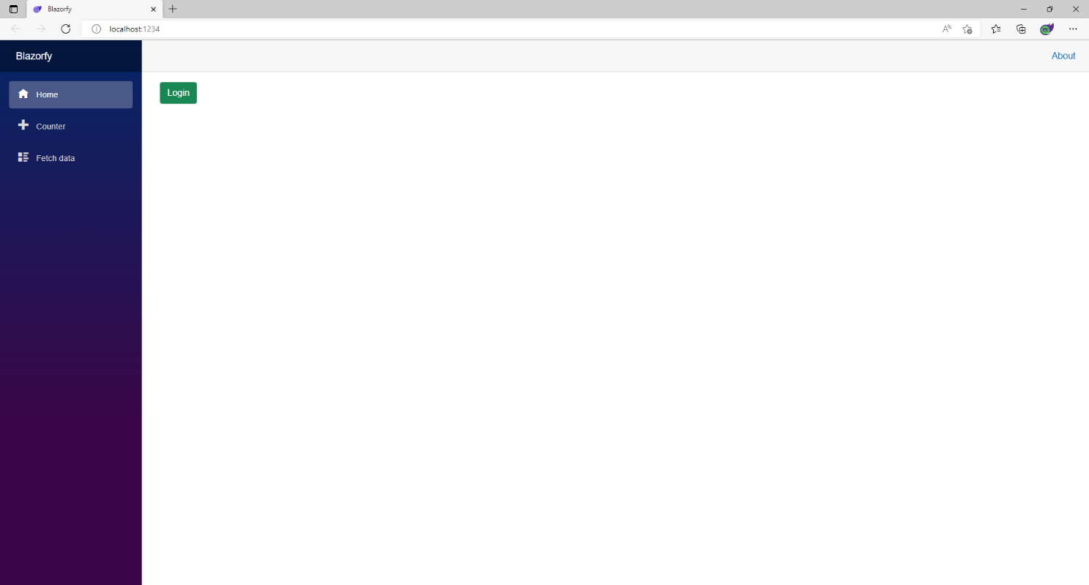

If you select the **Login** optionyou will be presented with something like the following where you should type in the **Email Address** for your **Account** and the **Password** and then select **Log In**

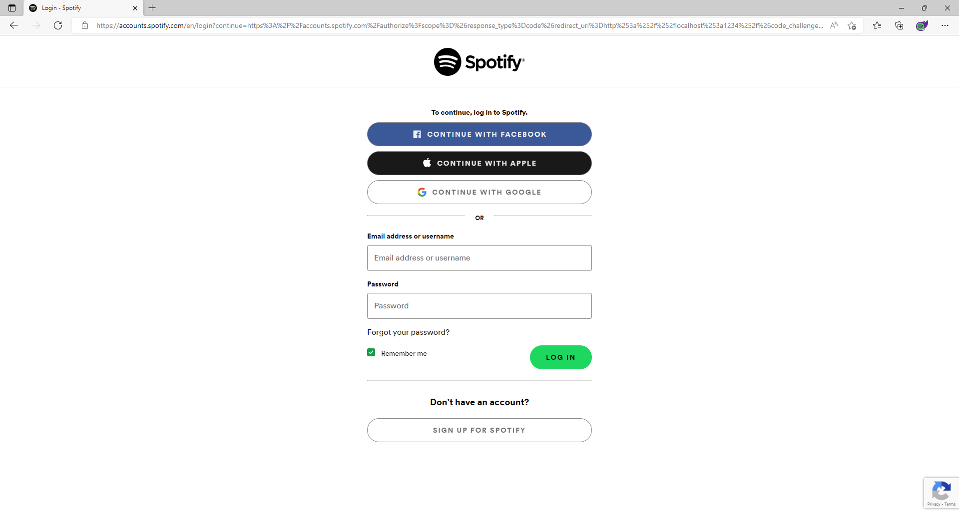

If for any reason you don’t see this screen then go over the previous steps in the **Workshop** to make sure you haven’t missed anything and also make sure you have an active **Internet** connection. If you do see this screen correctly then you can type in the **Email Address** from the list of **Accounts** for your number along with the **Password** and then select **Log In** you can leave the **Remember Me** option ticked so you can skip this step next time you try to login. If you get an **Error** at the bottom of the **Browser** and you don’t see any mistakes then you can **Refresh** the **Browser** and that might fix the problem!

Once you have selected **Log In** you should see something like the following **Authorise** page displayed:

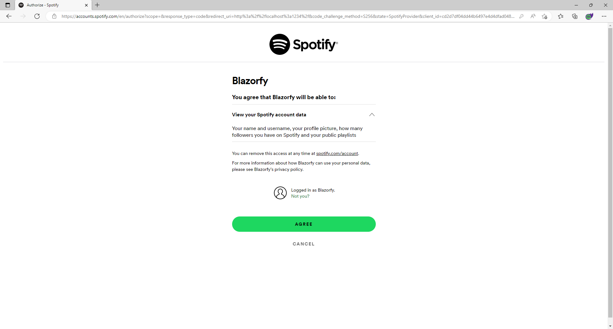

This will mention “**Blazorfy**” and what access it will have to **Account** data from **Spotify** which will just be enough to display **User** information, then you just need to select **Agree**.

Once you have selected **Agree** you will be redirected from **Spotify** back to **Blazorfy** and you should see the following which will display your **Username** next to the **Logout** option.

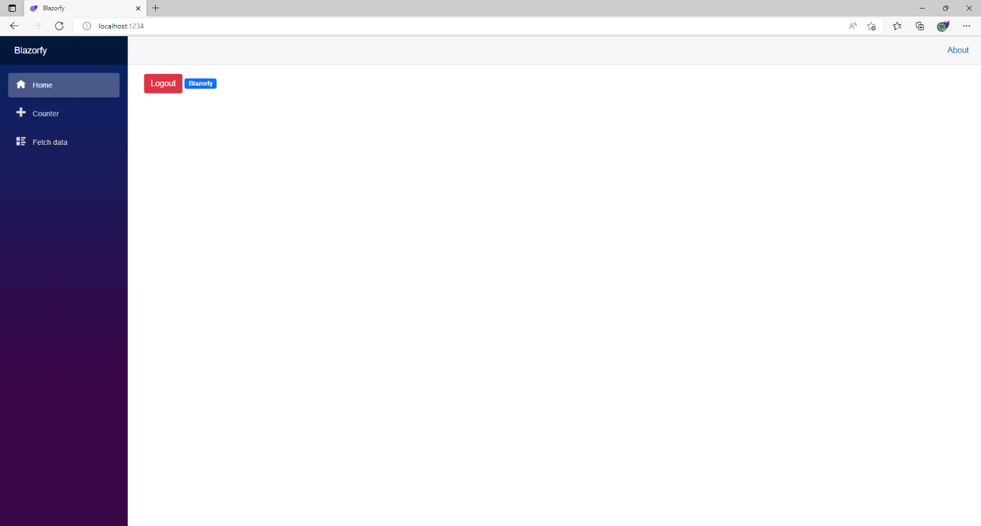

You can then select **Logout** which should Refresh the page and display **Login** and with that you have completed the **Authentication** part of the **Workshop**.

After the **Break** you will get a chance to add more **Pages** and some more functionality to the **Provider** to display information from the **Library** of content from **Spotify**!

# Library

In this part of the **Workshop** you will learn how to get information from the **Library** of content from **Spotify** including **Categories**, **Playlists**, **Albums** and **Podcasts**. You’ll build **Components** to display the details, add **Pages** for content from the **Library** and even create a **Component** that will allow you to see the same details using the **Spotify** application on your *iPhone* or *Android Phone* if you have **Spotify**!

## Categories

Here we’ll update the index page to show **Categories**, to do this return to **Visual Studio Code** for **Blazorfy** and then from **Explorer** select *SpotifyProvider.cs* as follows:

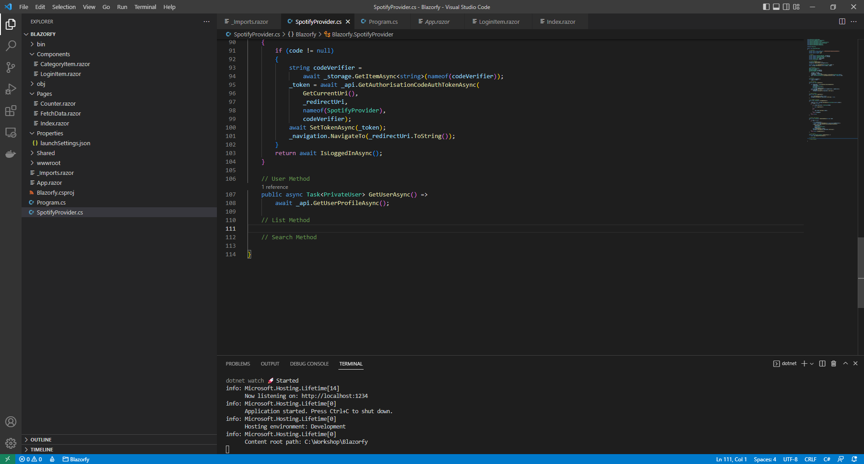

You should also still have open the **Browser** showing the Login option, if you don’t then in **Visual Studio Code** if it was still open select the **Terminal** and then press **Ctrl+C** in **Windows** or **Command+C** on **Mac** on the **Keyboard**,or if **Visual Studio Code** was closed relaunch **Visual Studio Code** and then select the **New** **Terminal** then in the **Terminal**. With the **Terminal** in **Visual Studio Code** open type the following which should relaunch the **Browser**.

dotnet watch

Then in **Visual Studio Code** within *SpotifyProvider.cs* you will define part of a **Method** that will be used to display the **Categories**, so below the **Comment** of **// List Method** type the following **Method**:

public async Task<List<TItem>> ListAsync<TItem>(string? id = null)

where TItem : class

{

var results = new List<TItem>();

var page = new Page() { Limit = total };

int count;

do

{

Paging<TItem>? items = null;

// Categories

if (typeof(TItem) == typeof(Category))

{

items = await _api.GetAllCategoriesAsync(page: page)

as Paging<TItem>;

}

// Playlists

// Albums

if (items != null)

{

results.AddRange(items.Items);

page.Offset += total;

}

count = items?.Count ?? 0;

}

while (count > 0 && results.Count < max && count == total);

return results;

}

This **Method** is a bit more complicated so feel free to **Copy** and **Paste** it into **Visual Studio Code** instead of typing it out. This **Method** uses a concept known as **Generics** which allows the **type** of a **class** to vary, when we had **string** and **int** before those were **types**. In this case there will be a **List** of a **class** which will be returned from this **Method**.

The first part of the **Method** uses the **Generic** syntax and also has a **List** of the items that will be returned. Then there is a **Page** that will be used to return the items up to the total that was defined earlier and there is a **Variable** of **count** to keep track of how many items have been retrieved.

This method then has a **do** – **while** which will keep looping when there are a number of items with **count**, the number of total items is less than the maximum with **max** and there are still items.

The **Spotify.NetStandard** package uses a **Paging** object to contain anything returned from **Spotify**. When we provide the **type** of **Category** it will use the **Method** of **GetAllCategoriesAsync** which will be of **Paging<Category>** which is converted to **Paging<TItem>** but **TItem** will actually be **Category** in this case.

Then there’s some logic to add what was obtained to results and go to the next **Page** where the loop will continue until any of the conditions being checked for are no longer satisfied. If you’d like to learn more about **Generics** then you can search for **.NET Generics** online.

Then while still in **Visual Studio Code** from **Explorer** select the **Folder** for **Components** then with the **Folder** for **Components** selected you should then select the **New File…** option and type in the name as follows then press **Enter**:

CategoryItem.razor

This will form the basis of another **Component** and will be a blank **Component** as follows:

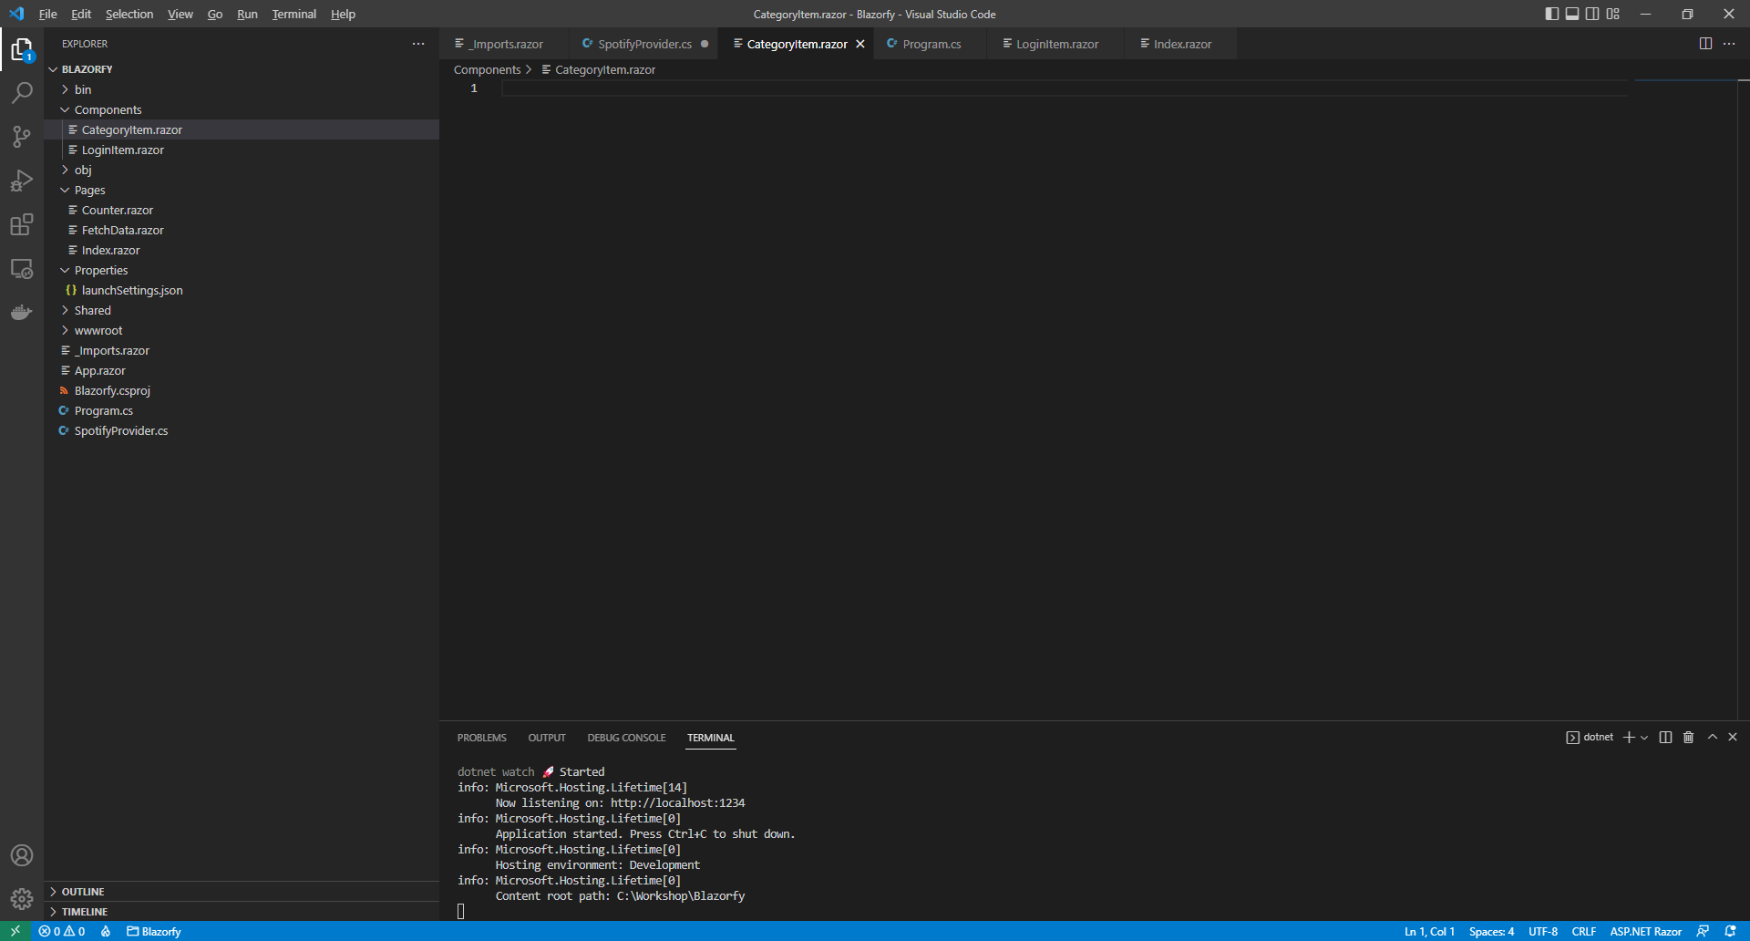

Within *CategoryItem.razor* in **Visual Studio Code** you can define this **Component** by typing in the following:

@namespace Blazorfy

<a href="playlists/@Value.Id">

<div class="card">

@if (Value.Images.Count > 0)

{

<img class="card-img-top"

src="@Value.Images[0].Url" alt="@Value.Name" />

}

<div class="card-body">

<h5 class="card-title">

@Value.Name

</h5>

</div>

</div>

</a>

@code

{

[Parameter]

public Category Value { get; set; } = new();

}

The first part of the **Component** is the **namespace** for the application which is **Blazorfy**. Then there is a link to a **Page** that will be created in the next part of the **Workshop** for **Playlists** which will pass through an **Id**.

Then there is some **HTML** to define the layout of the **Category Item** this includes a check to see if there are any **Images** with **if** that if **true** will then use the **img** to display the first image since **Images** is an **Array** you use the **[** and **]** to provide an **Index** in this case *0* to get it and we also set the **alt** of the **img** to the **Name** of the **Category** which is also displayed within a **h5** and the **Category** itself will be provided to the **Property** for **Value**.

Within **Visual Studio Code** from the **Explorer** for **Blazorfy** open **Pages** by selecting the **>** next to it and select **index.razor** as follows:

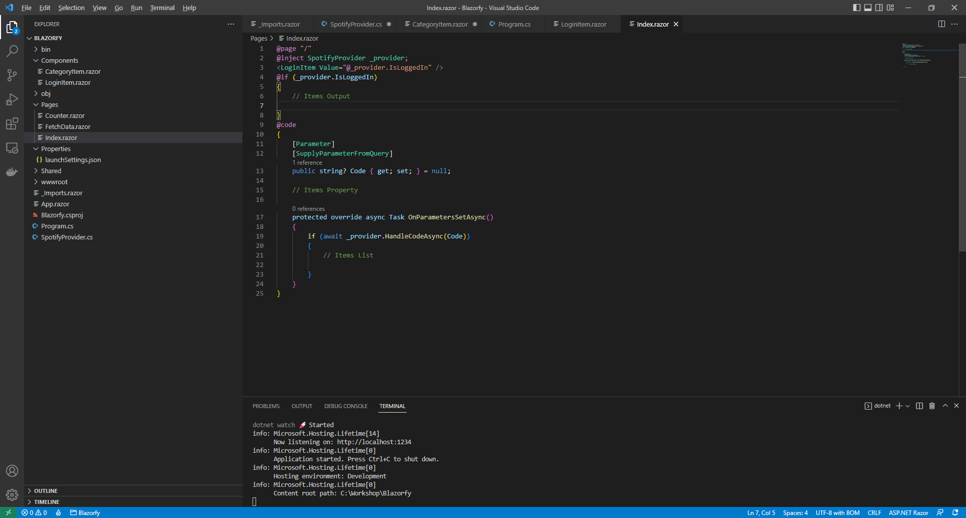

Within *Index.razor* in **Visual Studio Code** below the **Comment** of **// Items Property** type the following:

public List<Category> Items { get; set; } = new();

This **Property** will represent the **List** of **Category** that will be obtained from the **Provider**.

You can then go to the **Menu** in **Visual Studio Code** and select **File** and then **Save All** you may see in the **Terminal** a message saying **Do you want to restart your app - Yes (y) / No (n) / Always (a) / Never (v)?** you can select the **Terminal** then type **y** for **Yes** or **a** for **Always** to keep what you have done so far.

While still in *Index.razor* in **Visual Studio Code** below the **Comment** of **// Items List** type the following:

Items = await _provider.ListAsync<Category>();

This will use the **Method** of **ListAsync** that was defined earlier in the **Provider** with the **type** of **Category**.

Then while still in *Index.razor* and below the **Comment** of **// Items Output** type the following:

<h1>Categories</h1>

<div class="container">

<div class="row row-cols-1 row-cols-md-4 p-2 g-2">

@foreach (var item in Items)

{

<div class="col">

<CategoryItem Value="@item" />

</div>

}

</div>

</div>

This will be used to output the **Categories** from the **Property** of **Items** and also uses the **Component** of **CategoryItem** to display them.

Then in **Visual Studio Code** from the **Explorer** for **Blazorfy** open **Shared** by selecting the **>** next to it in **Explorer** and select **NavMenu.razor** as follows:

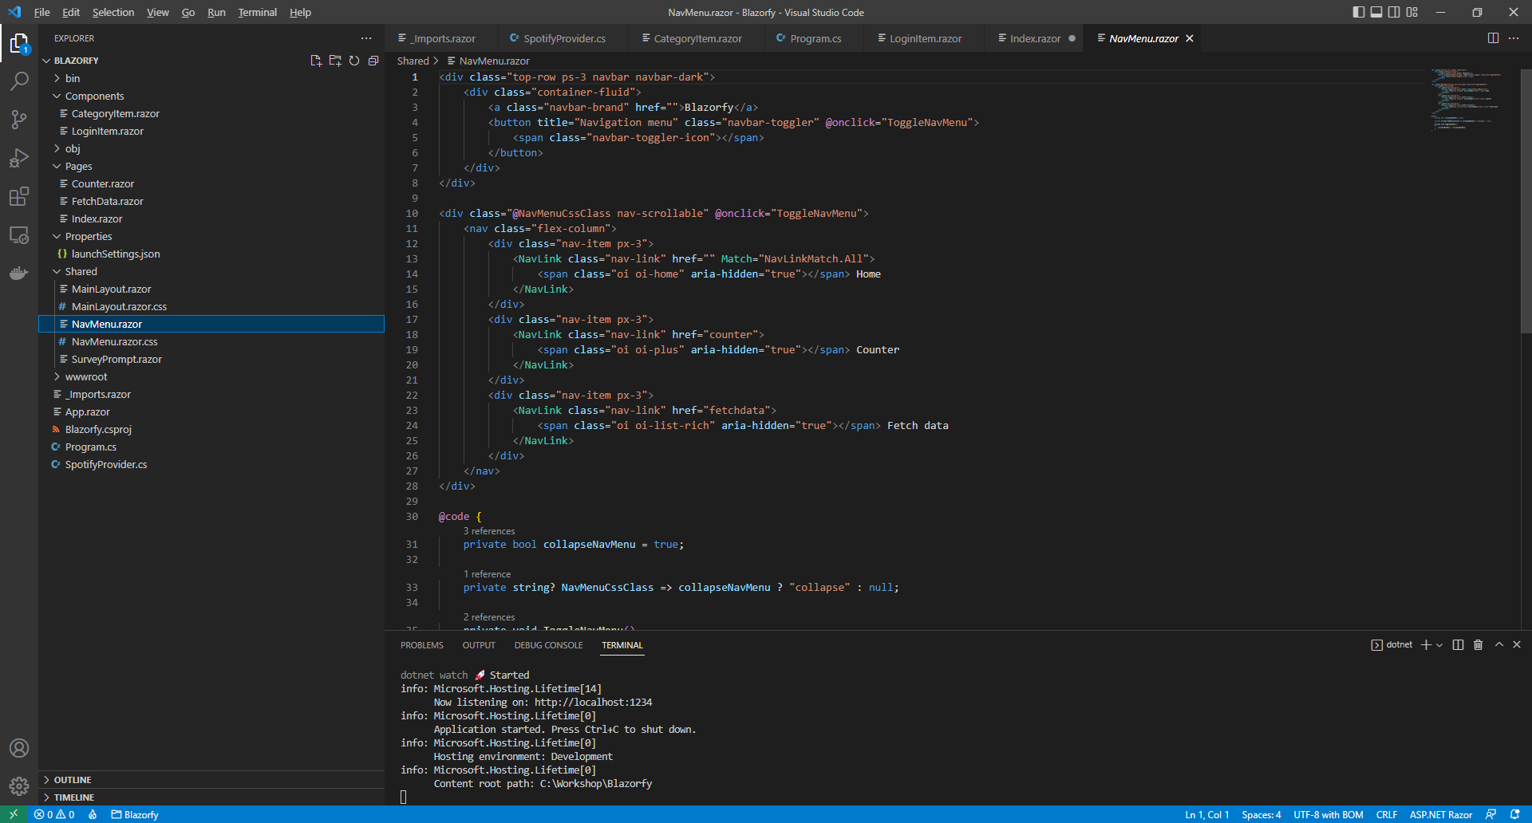

With *NavMenu.razor* selected where it says *Home*change this to say the following:

Categories

Then you can then go to the **Menu** in **Visual Studio Code** and select **File** and then **Save All** you may see in the **Terminal** a message saying **Do you want to restart your app - Yes (y) / No (n) / Always (a) / Never (v)?** you can select the **Terminal** then type **y** for **Yes** or **a** for **Always** to keep what you have done so far.

If you return to the **Browser** you will see an option to **Login** and the first option should be **Categories** as shown below:

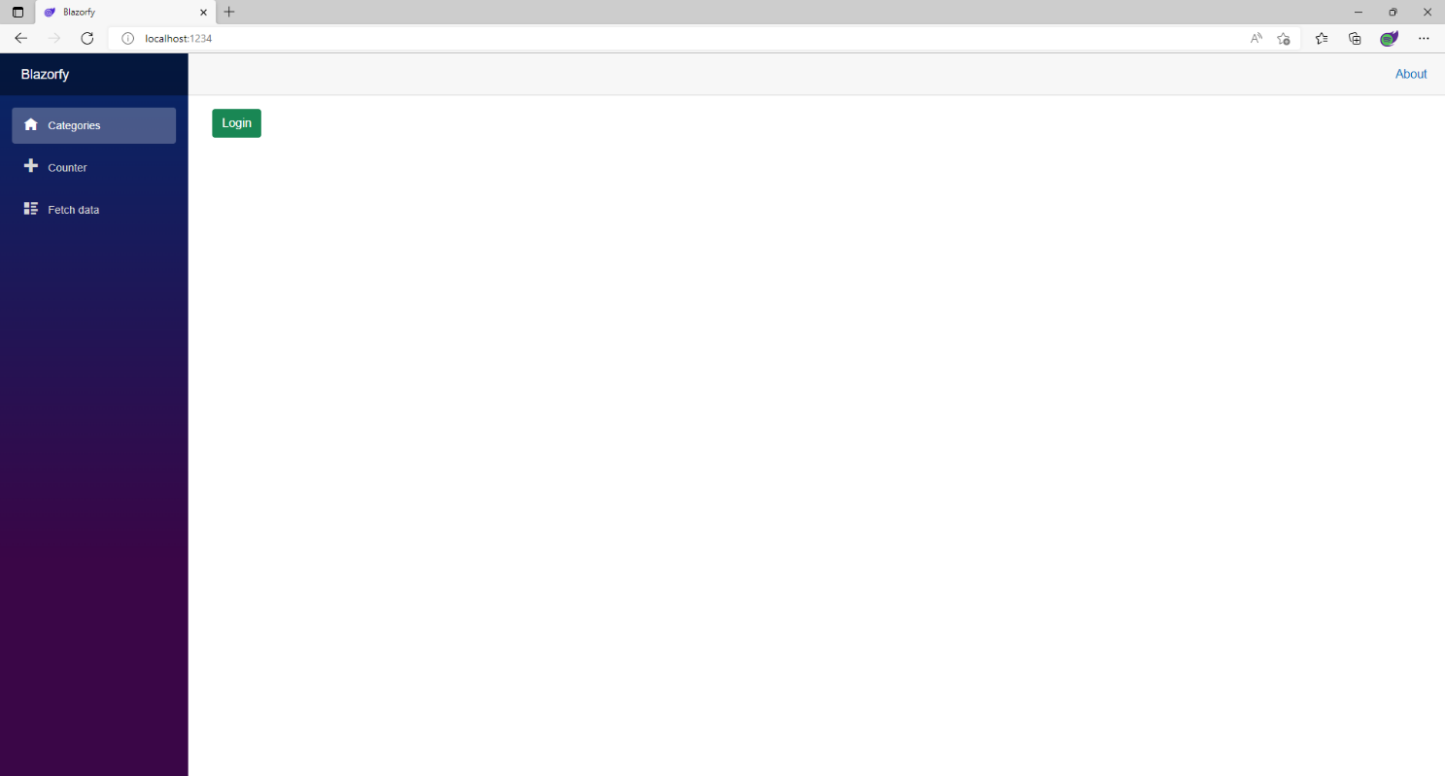

Once you have selected **Login** you should see something like the following **Authorise** page displayed:



Once you have selected **Agree** you will be redirected from **Spotify** back to **Blazorfy** and you should see the following which will display “**Blazor Workshop**”followed by your **Number** next to the **Logout** option and then below this will be the **Categories** similar to as follows:

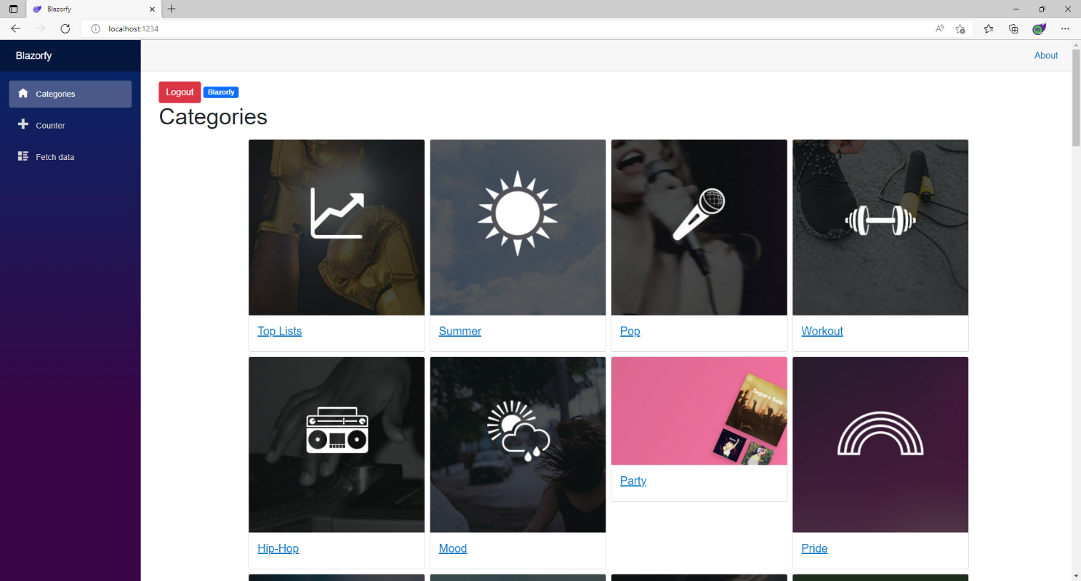

If you don’t see this list of **Categories** then go through the previous steps in the **Workshop** and check that you’ve not missed anything, you can **Copy** and **Paste** anything you’re not sure of from this if needed.

Each of the **Categories** has a link to a **Page** which will be created in the next part of the **Workshop** where you’ll get to build the **Page** for **Playlists** along with a special **Component** that you can use with the **Spotify** mobile application for *iPhone* and *Android*.

You’ll probably notice, if this is still the case that one of the images is not correct for **Party**, as part of **Spotify for Developers** there is a **Forum** where you can report issues and I’ve reported this incorrect asset to them, should this have been resolved then all the images should appear consistently.

## Playlists

We’ll add a new **Page** to show and **Search** for **Playlists** to do this return to **Visual Studio Code** for **Blazorfy** and then from **Explorer** select *SpotifyProvider.cs* as follows:

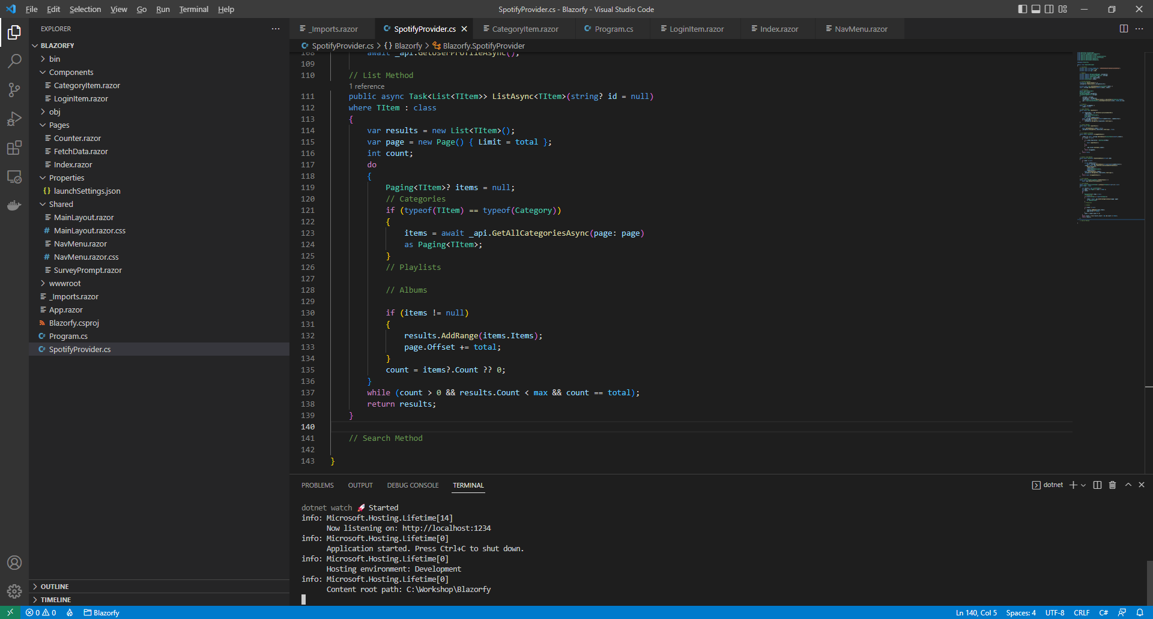

You should also still have open the **Browser** showing the Login option, if you don’t then in **Visual Studio Code** if it was still open select the **Terminal** and then press **Ctrl+C** in **Windows** or **Command+C** on **Mac** on the **Keyboard**,or if **Visual Studio Code** was closed relaunch **Visual Studio Code** and then select the **New** **Terminal** then in the **Terminal**. With the **Terminal** in **Visual Studio Code** open type the following which should relaunch the **Browser**.

dotnet watch

Then in **Visual Studio Code** within *SpotifyProvider.cs* you will define part of a **Method** that will be used to display the **Categories**, so below the **Comment** of **// Search Method** type the following **Method**:

public async Task<List<TItem>> SearchAsync<TItem>(string query)

where TItem : class

{

var results = new List<TItem>();

var page = new Page() { Limit = total };

int count;

do

{

Paging<TItem>? items = null;

var searchType = new SearchType()

{

Playlist = typeof(TItem) == typeof(SimplifiedPlaylist),

Album = typeof(TItem) == typeof(Album),

Show = typeof(TItem) == typeof(SimplifiedShow)

};

var content = await _api.SearchForItemAsync(query, searchType, page: page);

// Playlists

if (typeof(TItem) == typeof(SimplifiedPlaylist))

{

items = content.Playlists as Paging<TItem>;

}

// Albums

// Podcasts

if (items != null)

{

results.AddRange(items.Items);

page.Offset += total;

}

count = items?.Count ?? 0;

}

while (count > 0 && results.Count < max && count == total);

return results;

}

This **Method** is a bit more complicated so feel free to **Copy** and **Paste** it into **Visual Studio Code** instead of typing it out but you can still go through it to see if you can understand what is going on in the **Method**.

This **Method** also uses **Generics** and is very similar to **Method** for **ListAsync**. It has a few differences, this time it sets up a **SearchType** which has values that can be **true** or **false** to indicate the kind of **Search** and are using the **type** of the **Generic** to set this accordingly then using this with **SearchForItemAsync** and then for each **type** are getting the values for that.

There is also the use of **typeof** which is used to get the **type** of the **class** that is being used with the **Method**, this is useful as we can use this to define different behaviour depending on what **type** it is.

You’ll have noticed in the previous **Method** and this one for the **count** there are **?.** and **??** being used, the **?.** is known as the *Elvis Operator* and this will treat the value of **Count** as **null** if the value of items is and then **??** can then be used to use *0* in place of the **null**.

While stillwithin *SpotifyProvider.cs* in **Visual Studio Code** in the **Method** of **ListAsync** below the **Comment** of **// Playlists** type the following:

if (typeof(TItem) == typeof(SimplifiedPlaylist))

{

items = await _api.GetCategoryPlaylistsAsync(id, page: page)

as Paging<TItem>;

}

This part of the **Method** will use **GetCategoryPlaylistsAsync** to get the **Playlists** for a **Category**.

Then while still in **Visual Studio Code** from **Explorer** select the **Folder** for **Components** then with the **Folder** for **Components** selected you should then select the **New File…** option and type in the name as follows then press **Enter**:

Scannable.razor

This will form the basis of a shared **Component** and will be a blank **Component** as follows:

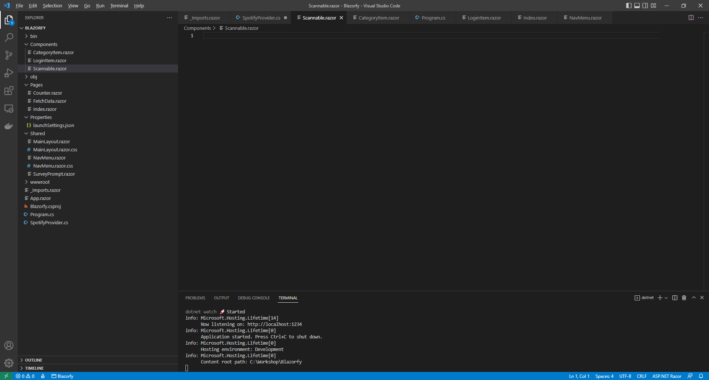

Within *Scannable.razor* in **Visual Studio Code** you can define the **Component** by typing in the following:

@namespace Blazorfy

<img class="img-fluid"

src="https://scannables.scdn.co/uri/plain/svg/5c2d91/white/640/@Value" />

@code

{

[Parameter]

public string Value { get; set; } = string.Empty;

}

This **Component** displays a special code that can be scanned using the **Spotify** application on *iPhone* or *Android* in an **img** and will use a passed in **Value** which forms part of **src**.

We can break down how the code or “scannable” itself is generated like so, the **svg** part of the **src** is the format of the image which can also be *png* or *jpeg* for those image formats.

The **5c2d91** part of the **src** is the background colour of the code and **white** is the foreground colour which can also be *black* then there is a number, in this case it is *640* which is the width of the image.

Finally the end part is the *URI* for a **Spotify** item such as a **Playlist** and other things you can share from **Spotify**, you can find out more about **Spotify Codes** at [spotifycodes.com](https://www.spotifycodes.com/).

Then you can then go to the **Menu** in **Visual Studio Code** and select **File** and then **Save All** you may see in the **Terminal** a message saying **Do you want to restart your app - Yes (y) / No (n) / Always (a) / Never (v)?** you can select the **Terminal** then type **y** for **Yes** or **a** for **Always** to keep what you have done so far.

Then while still in **Visual Studio Code** from **Explorer** select the **Folder** for **Components** then with the **Folder** for **Components** selected you should then select the **New File…** option and type in the name as follows then press **Enter**:

PlaylistItem.razor

This will form the basis of another **Component** and will be a blank **Component** as follows:

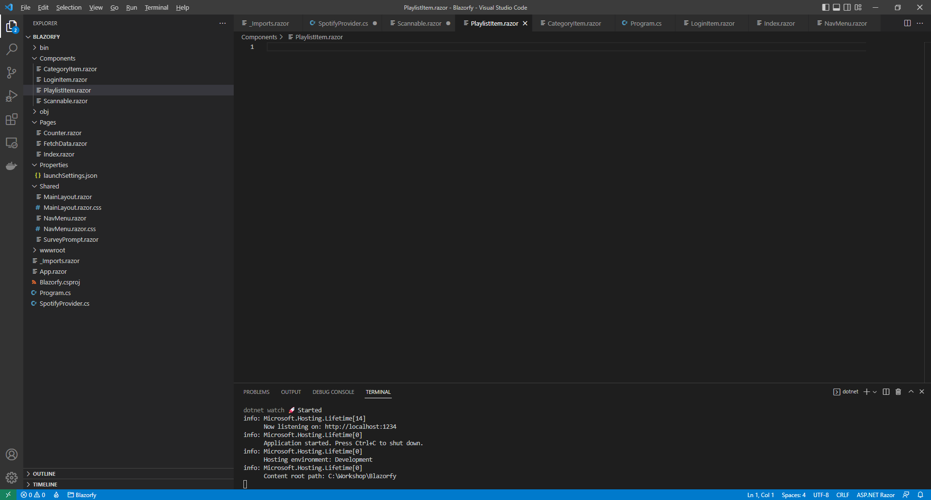

Within *PlaylistItem.razor* in **Visual Studio Code** you can define the **Component** by typing in the following:

@namespace Blazorfy

<div class="card">

@if (Value.Images.Count > 0)

{

<img src="@Value.Images[0].Url" class="card-img-top" alt="@Value.Name" />

}

<**Scannable** **Value**="@Value.Uri" />

<div class="card-body">

<h5 class="card-title">

@Value.Name

</h5>

</div>

</div>

@code

{

[Parameter]

public SimplifiedPlaylist Value { get; set; } = new();

}

The first part of the **Component** is the **namespace** for the application which is **Blazorfy**. Then there is some **HTML** to define the layout of a **Playlist Item** this includes a check to see if there are any **Images** with **if** that if **true** will then use the **img** to display the first image since **Images** is an **Array** you use the **[** and **]** to provide an **Index** in this case *0* to get it and we also set the **alt** of the **img** to the **Name** of the **Playlist** which is also displayed within a **h5** and the **Playlist** itself will be provided to the **Property** for **Value**. You’ll also see the inclusion of the **Component** for the **Scannable** which is provided with the **Uri** of the **Playlist**.

Then you can then go to the **Menu** in **Visual Studio Code** and select **File** and then **Save All** you may see in the **Terminal** a message saying **Do you want to restart your app - Yes (y) / No (n) / Always (a) / Never (v)?** you can select the **Terminal** then type **y** for **Yes** or **a** for **Always** to keep what you have done so far.

Then in **Visual Studio Code** from **Explorer** select the **Folder** for **Pages** then with the **Folder** for **Pages** selected you should then select the **New File…** option and type in the name as follows then press **Enter**:

PlaylistsPage.razor

This will form the basis of a **Page** and will be a blank **Page** as follows:

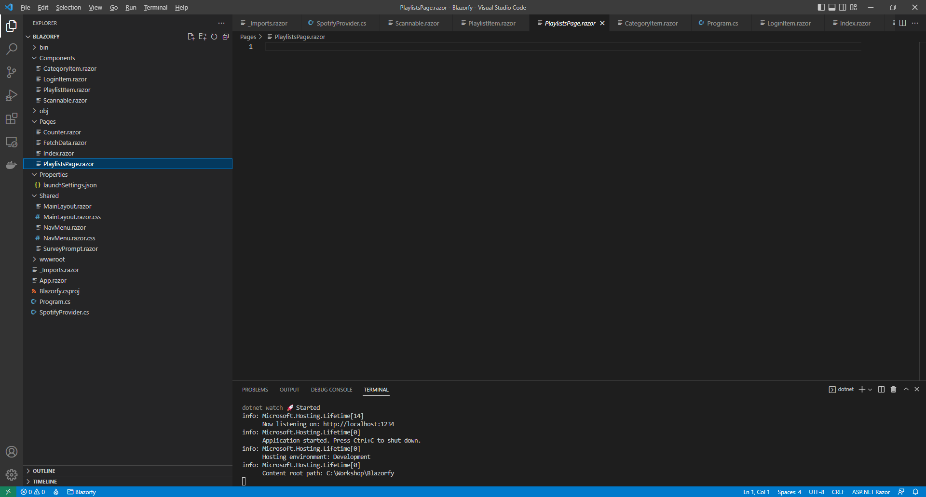

Within *PlaylistsPage.razor* in **Visual Studio Code** you can define the **Page** by typing in the following:

@page "/playlists/"

@page "/playlists/{id}"

@inject SpotifyProvider _provider;

<**LoginItem** **Value**="@_provider.IsLoggedIn" />

@if (_provider.IsLoggedIn)

{

// Items Output

}

@code

{

public List<SimplifiedPlaylist> Items { get; set; } = new();

[Parameter]

[SupplyParameterFromQuery]

public string? Search { get; set; }

[Parameter]

public string? Id { get; set; }

// Items Method

}

This **Page** includes two **page** directiveswhich create the **Routes** needed to navigate to this **Page** this includes the one from the **Category Item** which will provide the **Id** and another which will be used from the **Menu** later.

There is also an **inject** to provide the **Instance** of the **SpotifyProvider** using **Dependency Injection**. Then there is the **Component** of **LoginItem** with the **Value** being provided with the **Property** for **IsLoggedIn** from the **class**.

There is also the **Property** for **Items** to be displayed in the **Page** along with a **Property** for the **Search** that will be provided, which will be from a query to the page from a **Form** which is denoted with the **Attribute** of **SupplyParameterFromQuery** or one for **Id** should this be provided as a **Parameter**.

While still within *PlaylistsPage.razor* in **Visual Studio Code** and below the **Comment** for **// Items Method** type the following **Method**:

protected async override Task OnParametersSetAsync()

{

Items.Clear();

if (await _provider.IsLoggedInAsync())

{

if (Search != null)

{

Items = await _provider.SearchAsync<SimplifiedPlaylist>(Search);

}

else

{

if (Id != null)

{

Items = await _provider.ListAsync<SimplifiedPlaylist>(Id);

}

}

}

}

This is a special **Method** where the implementation of which has been overridden to provide our own denoted with **override** in this case it is for **OnParametersSetAsync**.

This will use **Clear** on **Items** to reset it and then will check if the user is logged in, then it checks to see if **Search** has a value other than **null**, if it does then it will use the **Method** of **SearchAsync** and provide the value to this, otherwise it will then check if the **Id** has a value, which it will should this be from the link from the **Category Item** which provides this to the **Page** and will use the **Method** of **ListAsync** instead.

Finally while still within *PlaylistsPage.razor* in **Visual Studio Code** and below the **Comment** for **// Items Output** type the following:

@if (string.IsNullOrEmpty(Id))

{

<h1>Search @Search</h1>

<form @onsubmit="OnParametersSetAsync">

<input type="text" @bind="Search" @bind:event="oninput" />

<button class="btn btn-primary">Search</button>

</form>

}

else

{

<h1>Playlists</h1>

}

<div class="container">

<div class="row row-cols-1 row-cols-md-4 p-2 g-2">

@foreach (var item in Items)

{

<div class="col">

<**PlaylistItem** **Value**="@item" />

</div>

}

</div>

</div>

This defines how the **Page** will look,the first part will check if the **Id** is not present, that is not be **null** or an empty **string** then if this is the case then it will display a **title** along with **form** to perform a **Search** this has an **input** which is where the **Playlist** being looked for will be typed in and then there is a **button** to perform the **Search**.

Should the **Id** be present then it will display different **title**. Below these the **Component** for the **Playlist Item** will be used to display the **Playlists**.

Then you can then go to the **Menu** in **Visual Studio Code** and select **File** and then **Save All** you may see in the **Terminal** a message saying **Do you want to restart your app - Yes (y) / No (n) / Always (a) / Never (v)?** you can select the **Terminal** then type **y** for **Yes** or **a** for **Always** to keep what you have done so far.

Then in **Visual Studio Code** from the **Explorer** for **Blazorfy** open **Shared** by selecting the **>** next to it in **Explorer** and select **NavMenu.razor** as follows:

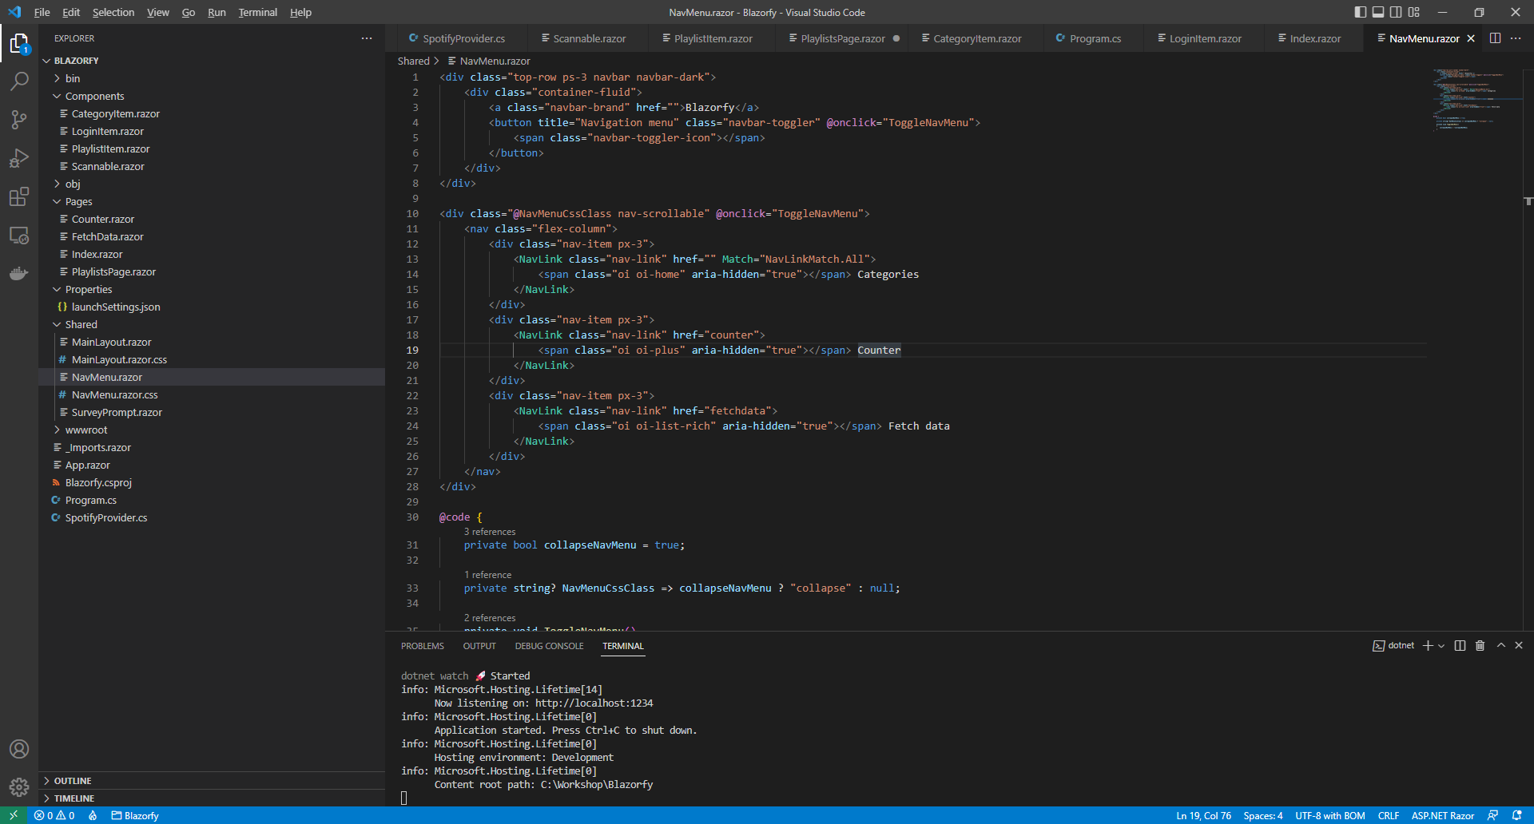

With *NavMenu.razor* selected there will be a section for *Counter*as follows:

<div class="nav-item px-3">

<**NavLink** class="nav-link" href="counter">

<span class="oi oi-plus" aria-hidden="true"></span> Counter

</**NavLink**>

</div>

Change where it says *counter* in **href** to be as follows:

playlists

Then you will need to change where it says *oi-plus* in the **span** to be as follows:

oi-list

Next you will need to change where it says *Counter* to be as follows:

Playlists

Then you can then go to the **Menu** in **Visual Studio Code** and select **File** and then **Save All** you may see in the **Terminal** a message saying **Do you want to restart your app - Yes (y) / No (n) / Always (a) / Never (v)?** you can select the **Terminal** then type **y** for **Yes** or **a** for **Always** to keep what you have done so far.

If you return to the **Browser** you will see the **Categories** along with a link to **Playlists** as shown below:

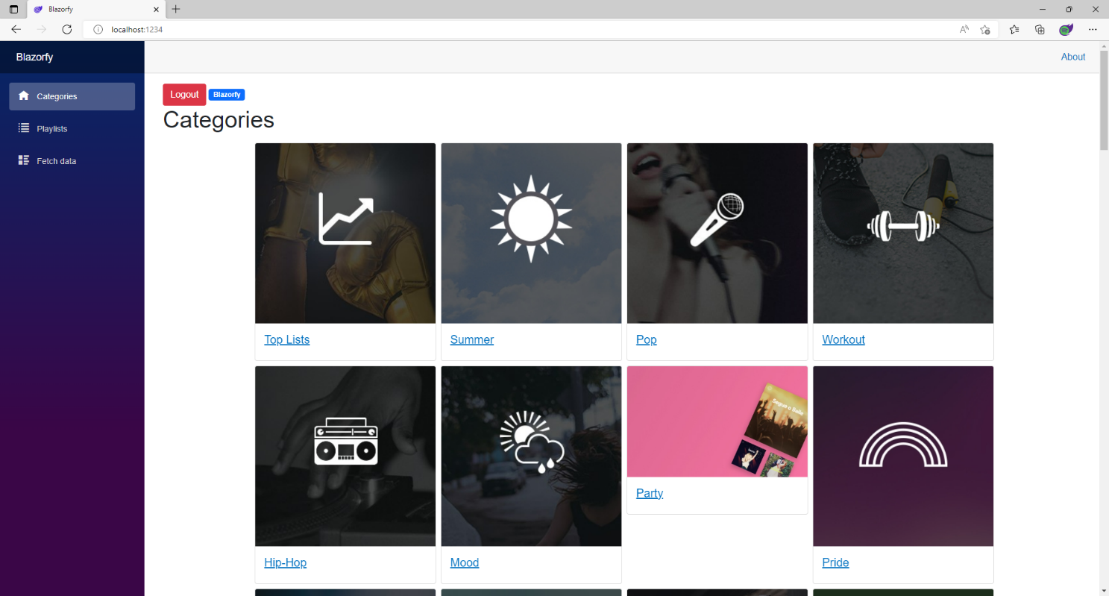

You can then select one of the **Categories** and you should see a list of **Playlists** similar to as follows:

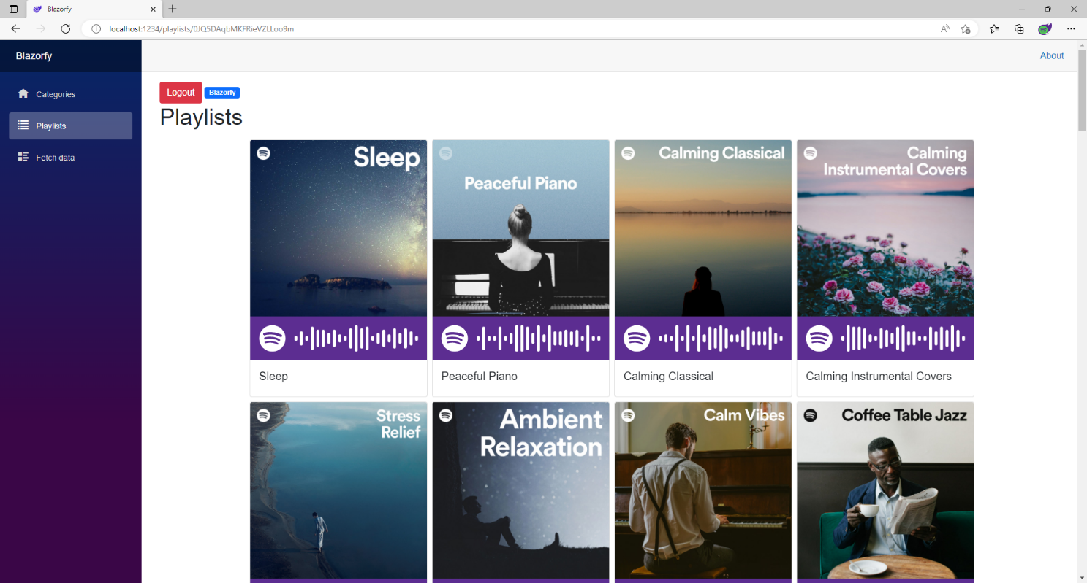

You can also select the **Playlists** option from the **Menu** and then type in your favourite **Artist** or anything else and then select **Search** to find related **Playlists**. You’ll also notice underneath each **Playlist** is a **Spotify Code**, if you have **Spotify** on your *iPhone* or *Android* device you can use the option to scan these using the app and can then checkout the **Playlist** for yourself.

If you don’t see anything then check that you’ve completed each part correctly and double-check that what you have is the same, if everything is working then you can proceed to the next part of the **Workshop**.

## Albums

We’ll add a new **Page** to show and **Search** for **Albums** to do this return to **Visual Studio Code** for **Blazorfy** and then from **Explorer** select *SpotifyProvider.cs* as follows:

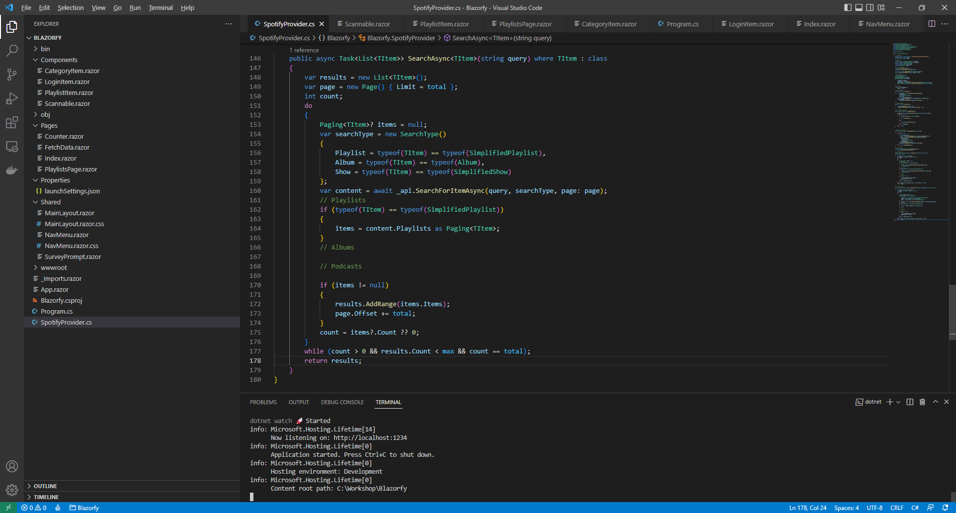

You should also still have open the **Browser** showing the Login option, if you don’t then in **Visual Studio Code** if it was still open select the **Terminal** and then press **Ctrl+C** in **Windows** or **Command+C** on **Mac** on the **Keyboard**,or if **Visual Studio Code** was closed relaunch **Visual Studio Code** and then select the **New** **Terminal** then in the **Terminal**. With the **Terminal** in **Visual Studio Code** open type the following which should relaunch the **Browser**.

dotnet watch

Then in **Visual Studio Code** within *SpotifyProvider.cs* you will define part of the **Method** that will be used to get **New Releases** of **Albums**. In the **Method** of **ListAsync** and below the **Comment** of **// Albums** type the following:

if (typeof(TItem) == typeof(Album))

{

items = await _api.GetAllNewReleasesAsync(page: page)

as Paging<TItem>;

}

This part of the **Method** will be used to get the **New Releases** from **Spotify** when the **type** is **Album**.

While stillwithin *SpotifyProvider.cs* you will define part of the **Method** that will be used to **Search** for **Albums**. In the **Method** of **SearchAsync** and below the **Comment** of **// Albums** type the following:

if (typeof(TItem) == typeof(Album))

{

items = content.Albums as Paging<TItem>;

}

This will get the **Albums** that are returned when the **SearchType** is **Album**, which is determined in **SearchAsync** by checking if the **type** that is used is an **Album** and setting the value for this accordingly.

Then you can then go to the **Menu** in **Visual Studio Code** and select **File** and then **Save All** you may see in the **Terminal** a message saying **Do you want to restart your app - Yes (y) / No (n) / Always (a) / Never (v)?** you can select the **Terminal** then type **y** for **Yes** or **a** for **Always** to keep what you have done so far.

Then while still in **Visual Studio Code** from **Explorer** select the **Folder** for **Components** then with the **Folder** for **Components** selected you should then select the **New File…** option and type in the name as follows then press **Enter**:

AlbumItem.razor

This will form the basis of another **Component** and will be a blank **Component** as follows:

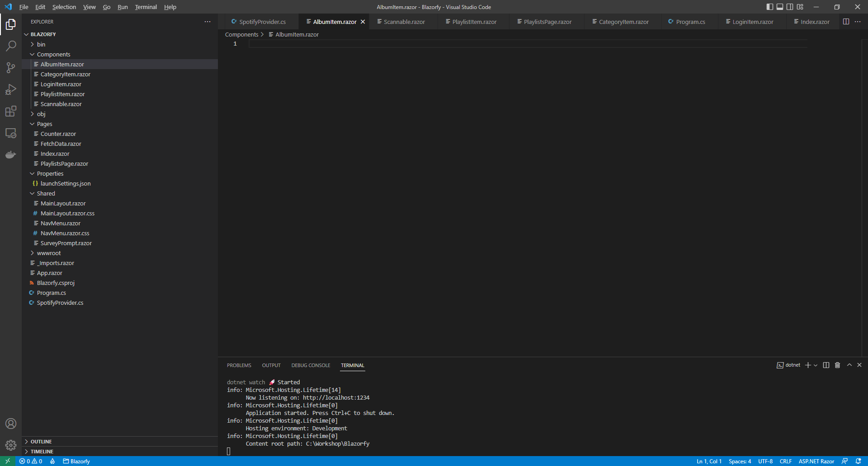

Within *AlbumItem.razor* in **Visual Studio Code** you can define the **Component** by typing in the following:

@namespace Blazorfy

<div class="card">

@if (Value.Images.Count > 0)

{

<img src="@Value.Images[0].Url" class="card-img-top" alt="@Value.Name" />

}

<**Scannable** **Value**="@Value.Uri" />

<div class="card-body">

<h5 class="card-title">

@Value.Name

</h5>

</div>

</div>

@code

{

[Parameter]

public SimplifiedAlbum Value { get; set; } = new();

}

The first part of the **Component** is the **namespace** for the application which is **Blazorfy**. Then there is some **HTML** to define the layout of an **Album Item** this includes a check to see if there are any **Images** with **if** that if **true** will then use the **img** to display the first image since **Images** is an **Array** you use the **[** and **]** to provide an **Index** in this case *0* to get it and we also set the **alt** of the **img** to the **Name** of the **Album** which is also displayed within a **h5** and the **Album** itself will be provided to the **Property** for **Value**.

You’ll also see the inclusion of the **Component** for the **Scannable** which is provided with the **Uri** of the **Album**.

This **Component** is identical to the one for **Playlist** but you could **Optionally** include different information such as the **Artist** for the **Album** as **SimplifiedAlbum** has a **Property** for a **List** of **Artists** that could be used for this purpose that you could add to this **Component**.

Then you can then go to the **Menu** in **Visual Studio Code** and select **File** and then **Save All** you may see in the **Terminal** a message saying **Do you want to restart your app - Yes (y) / No (n) / Always (a) / Never (v)?** you can select the **Terminal** then type **y** for **Yes** or **a** for **Always** to keep what you have done so far.

Then in **Visual Studio Code** from **Explorer** select the **Folder** for **Pages** then with the **Folder** for **Pages** selected you should then select the **New File…** option and type in the name as follows then press **Enter**:

AlbumsPage.razor

This will form the basis of a **Page** and will be a blank **Page** as follows:

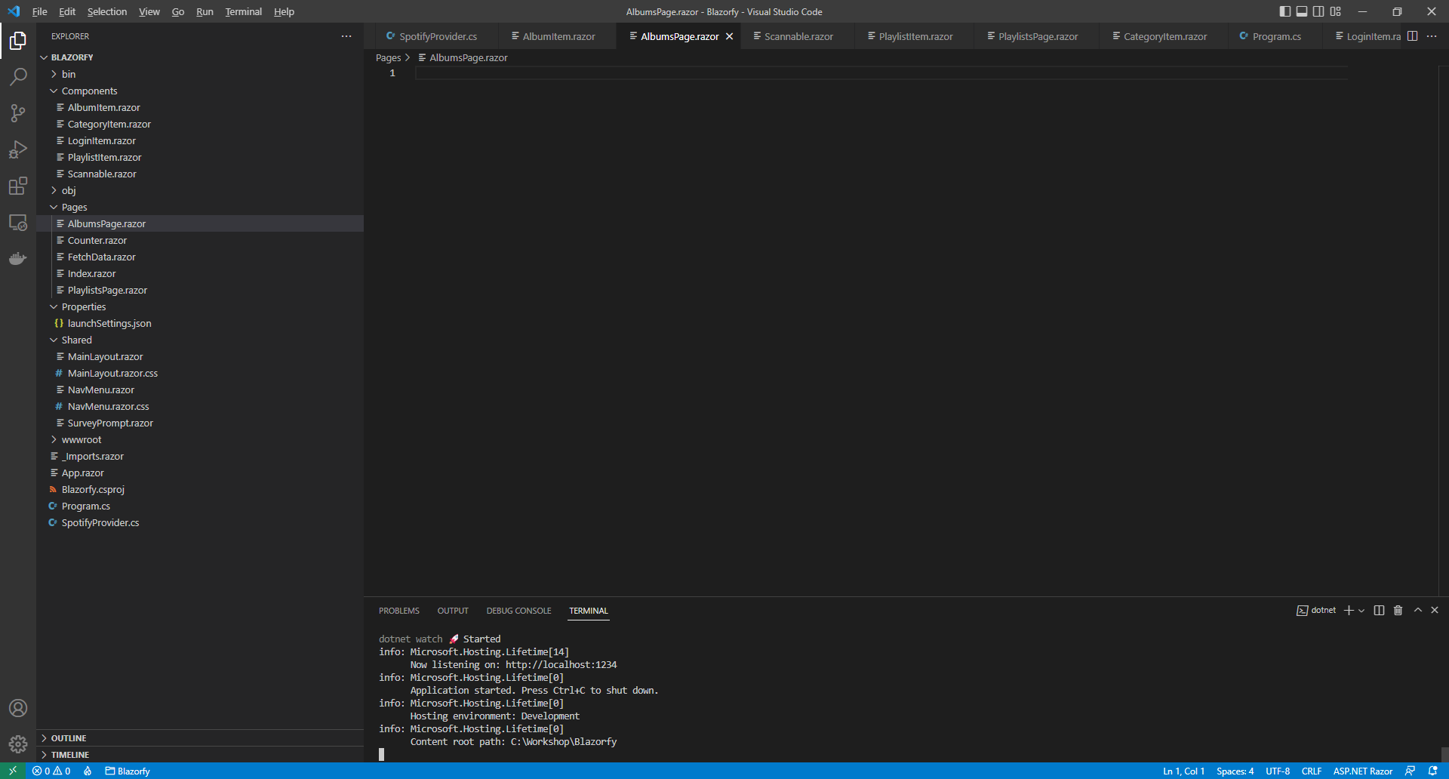

Within *AlbumsPage.razor* in **Visual Studio Code** you can define the **Page** by typing in the following:

@page "/albums"

@inject SpotifyProvider _provider;

<**LoginItem** **Value**="@_provider.IsLoggedIn" />

@if (_provider.IsLoggedIn)

{

// Items Output

}

@code

{

public List<Album> Items { get; set; } = new();

[Parameter]

[SupplyParameterFromQuery]

public string? Search { get; set; }

// Items Method

}

This **Page** includes a **page** directivewhich create a **Route** needed to navigate to this **Page** which will be used from the **Menu** later.

There is also an **inject** to provide the **Instance** of the **SpotifyProvider** using **Dependency Injection** and then there is the **Component** of **LoginItem** with the **Value** being provided with the **Property** for **IsLoggedIn** from the **class**.

There is also the **Property** for **Items** to be displayed in the **Page** along with a **Property** for the **Search** that will be provided, which will be from a query to the page from a **Form** which is denoted with the **Attribute** of **SupplyParameterFromQuery**.

While still within *PlaylistsPage.razor* in **Visual Studio Code** and below the **Comment** for **// Items Method** type the following **Method**:

protected override async Task OnParametersSetAsync()

{

Items.Clear();

if (await _provider.IsLoggedInAsync())

{

if (Search != null)

{

Items = await _provider.SearchAsync<Album>(Search);

}

else

{

Items = await _provider.ListAsync<Album>();

}

}

}

This is a special **Method** where the implementation of which has been overridden to provide our own denoted with **override** in this case it is for **OnParametersSetAsync**.

This will use **Clear** on **Items** to reset it and then will check if the user is logged in, then it checks to see if **Search** has a value other than **null**, if it does then it will use the **Method** of **SearchAsync** and provide the value to this with the **type** of **Album** otherwise it will use the **Method** of **ListAsync** with the **type** of **Album**.

Finally while still within *AlbumsPage.razor* in **Visual Studio Code** and below the **Comment** for **// Items Output** type the following:

@if (string.IsNullOrWhiteSpace(Search))

{

<h1>New Releases</h1>

}

else

{

<h1>Search @Search</h1>

}

<form @onsubmit="OnParametersSetAsync">

<input type="text" @bind="Search" @bind:event="oninput" />

<button class="btn btn-primary">Search</button>

</form>

<div class="container">

<div class="row row-cols-1 row-cols-md-4 p-2 g-2">

@foreach (var item in Items)

{

<div class="col">

<**AlbumItem** **Value**="@item" />

</div>

}

</div>

</div>

This defines how the **Page** will look,the first part will check if the **Search** is not be **null** or an empty **string** then if this is the case then it will display a **title** as *New* Releases or as *Search*.

Then there is a **form** to perform a **Search** this has an **input** which is where the **Album** being looked for will be typed in and then there is a **button** to perform the **Search** and below this the **Component** for the **Album Item** will be used to display the **Albums**.

Then you can then go to the **Menu** in **Visual Studio Code** and select **File** and then **Save All** you may see in the **Terminal** a message saying **Do you want to restart your app - Yes (y) / No (n) / Always (a) / Never (v)?** you can select the **Terminal** then type **y** for **Yes** or **a** for **Always** to keep what you have done so far.

Then in **Visual Studio Code** from the **Explorer** for **Blazorfy** open **Shared** by selecting the **>** next to it in **Explorer** and select **NavMenu.razor** as follows:

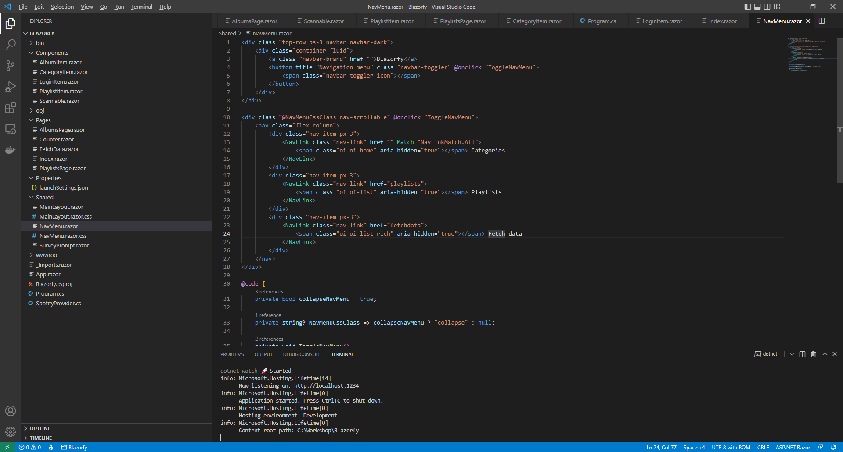

With *NavMenu.razor* selected there will be a section for *Fetch Data*as follows:

<div class="nav-item px-3">

<**NavLink** class="nav-link" href="fetchdata">

<span class="oi oi-list-rich" aria-hidden="true"></span> Fetch data

</**NavLink**>

</div>

Change where it says *fetchdata* in **href** to be as follows:

albums

Then you will need to change where it says *oi-list-rich* in the **span** to be as follows:

oi-musical-note

Next you will need to change where it says *Fetch Data* to be as follows:

Albums

Then you can then go to the **Menu** in **Visual Studio Code** and select **File** and then **Save All** you may see in the **Terminal** a message saying **Do you want to restart your app - Yes (y) / No (n) / Always (a) / Never (v)?** you can select the **Terminal** then type **y** for **Yes** or **a** for **Always** to keep what you have done so far.

If you return to the **Browser** you should be where you left off but there will now be an **Albums** option in the **Menu** as shown below:

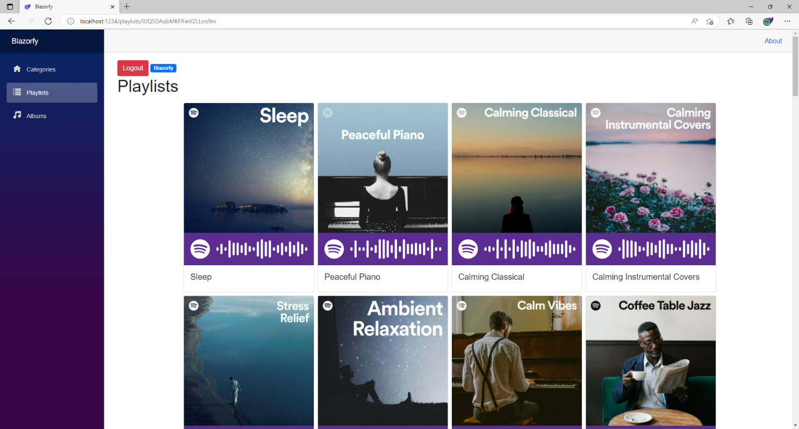

You can then select **Albums** and you should see a list of **New Releases** of **Albums** similar to as follows:

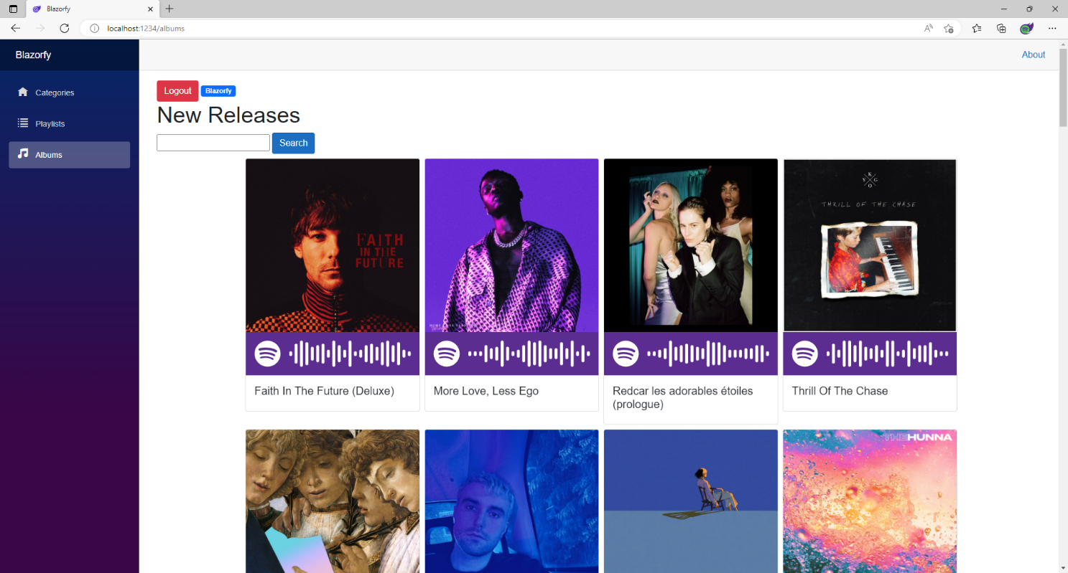

You can also type in your favourite **Album** and then select **Search** to find it. You’ll also notice underneath each **Album** is a **Spotify Code**, if you have **Spotify** on your *iPhone* or *Android* device you can use the option to scan these using the app and can then checkout the **Album** for yourself.

If you don’t see anything then check that you’ve completed each part correctly and double-check that what you have is the same, if everything is working then you can proceed to the next part of the **Workshop**.

## Podcasts

We’ll add a new **Page** to **Search** for **Podcasts**, to do this return to **Visual Studio Code** for **Blazorfy** and then from **Explorer** select *SpotifyProvider.cs* as follows:

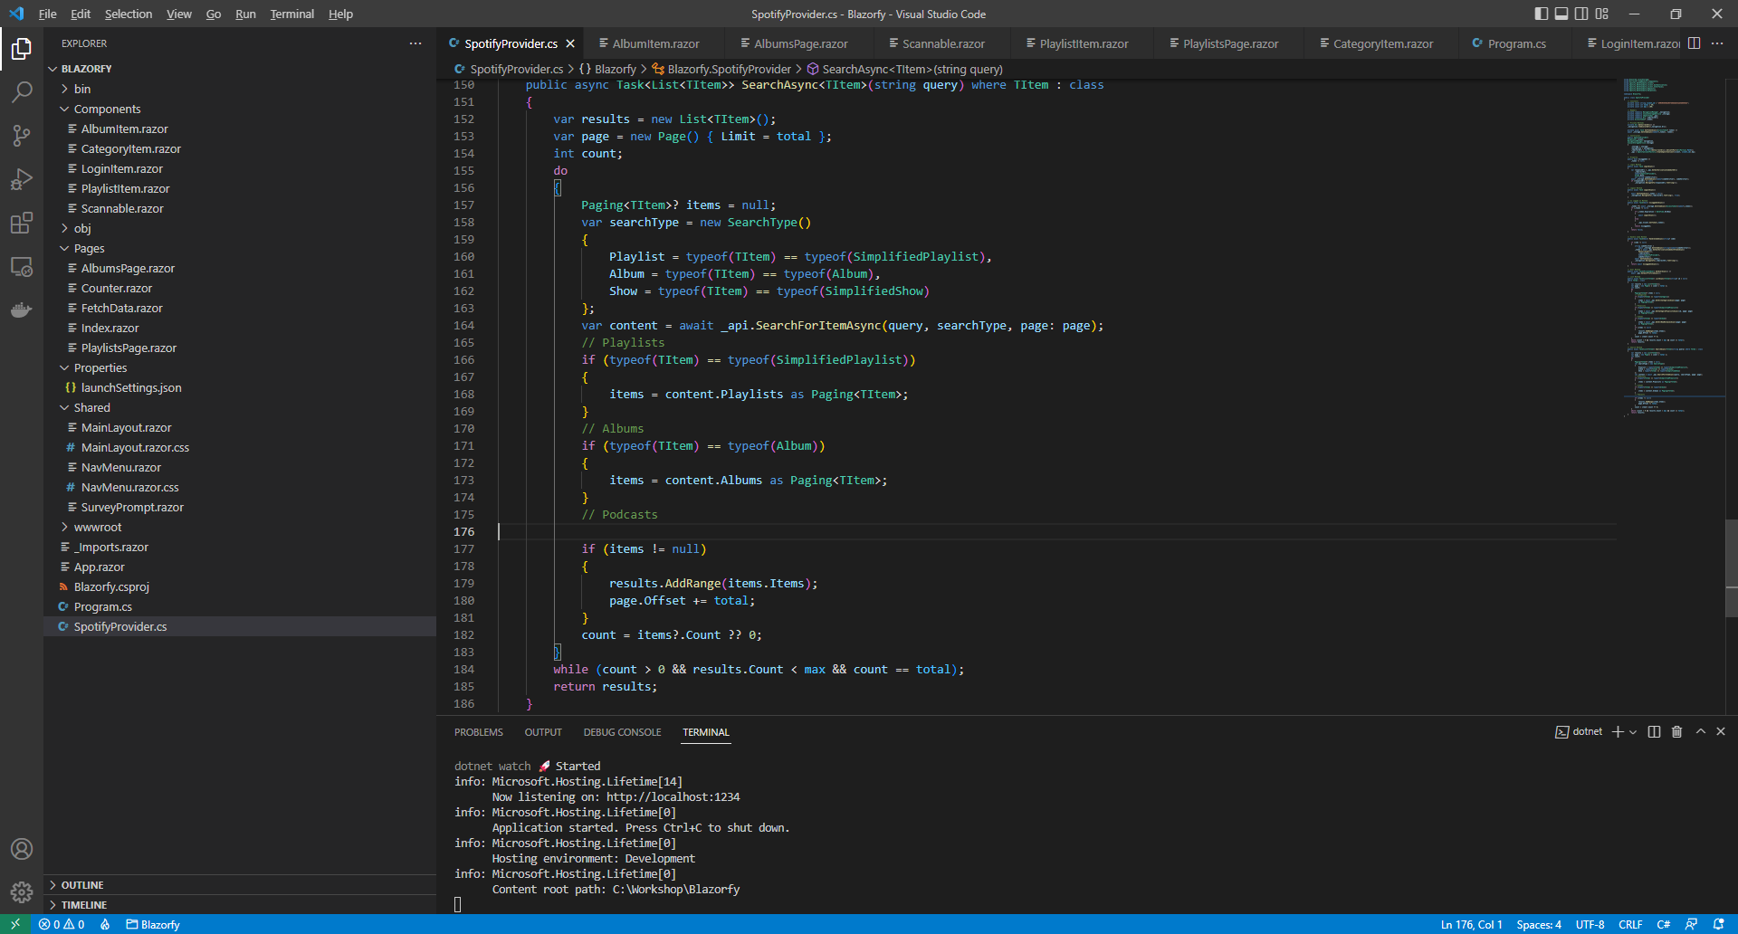

You should also still have open the **Browser** showing the Login option, if you don’t then in **Visual Studio Code** if it was still open select the **Terminal** and then press **Ctrl+C** in **Windows** or **Command+C** on **Mac** on the **Keyboard**,or if **Visual Studio Code** was closed relaunch **Visual Studio Code** and then select the **New** **Terminal** then in the **Terminal**. With the **Terminal** in **Visual Studio Code** open type the following which should relaunch the **Browser**.

dotnet watch

Then in **Visual Studio Code** within *SpotifyProvider.cs* you will define part of the **Method** that will be used to get **New Releases** of **Albums**. In the **Method** of **SearchAync** and below the **Comment** of **// Podcasts** type the following:

if (typeof(TItem) == typeof(SimplifiedShow))

{

items = content.Shows as Paging<TItem>;

}

This part of the **Method** will be used to **Search** for Podcasts from **Spotify** when the **type** is **SimplifiedShow**.

Then you can then go to the **Menu** in **Visual Studio Code** and select **File** and then **Save All** you may see in the **Terminal** a message saying **Do you want to restart your app - Yes (y) / No (n) / Always (a) / Never (v)?** you can select the **Terminal** then type **y** for **Yes** or **a** for **Always** to keep what you have done so far.

Then while still in **Visual Studio Code** from **Explorer** select the **Folder** for **Components** then with the **Folder** for **Components** selected you should then select the **New File…** option and type in the name as follows then press **Enter**:

PodcastItem.razor

This will form the basis of another **Component** and will be a blank **Component** as follows:



Within *PodcastItem.razor* in **Visual Studio Code** you can define the **Component** by typing in the following:

@namespace Blazorfy

<div class="card">

@if (Value.Images.Count > 0)

{

<img src="@Value.Images[0].Url" class="card-img-top" alt="@Value.Name" />

}

<**Scannable** **Value**="@Value.Uri" />

<div class="card-body">

<h5 class="card-title">

@Value.Name

</h5>

</div>

</div>

@code

{

[Parameter]

public SimplifiedShow Value { get; set; } = new();

}

The first part of the **Component** is the **namespace** for the application which is **Blazorfy**. Then there is some **HTML** to define the layout of the **Podcast Item** this includes a check to see if there are any **Images** with **if** that if **true** will then use the **img** to display the first image since **Images** is an **Array** you use the **[** and **]** to provide an **Index** in this case *0* to get it and we also set the **alt** of the **img** to the **Name** of the **Podcast** which is also displayed within a **h5** and the **Podcast** itself will be provided to the **Property** for **Value**.

You’ll also see the inclusion of the **Component** for the **Scannable** which is provided with the **Uri** of the **Podcast**, within **Spotify** **for Developers** a **Podcast** is called a **Show**.

Then you can then go to the **Menu** in **Visual Studio Code** and select **File** and then **Save All** you may see in the **Terminal** a message saying **Do you want to restart your app - Yes (y) / No (n) / Always (a) / Never (v)?** you can select the **Terminal** then type **y** for **Yes** or **a** for **Always** to keep what you have done so far.

Then in **Visual Studio Code** from **Explorer** select the **Folder** for **Pages** then with the **Folder** for **Pages** selected you should then select the **New File…** option and type in the name as follows then press **Enter**:

PodcastsPage.razor

This will form the basis of a **Page** and will be a blank **Page** as follows:

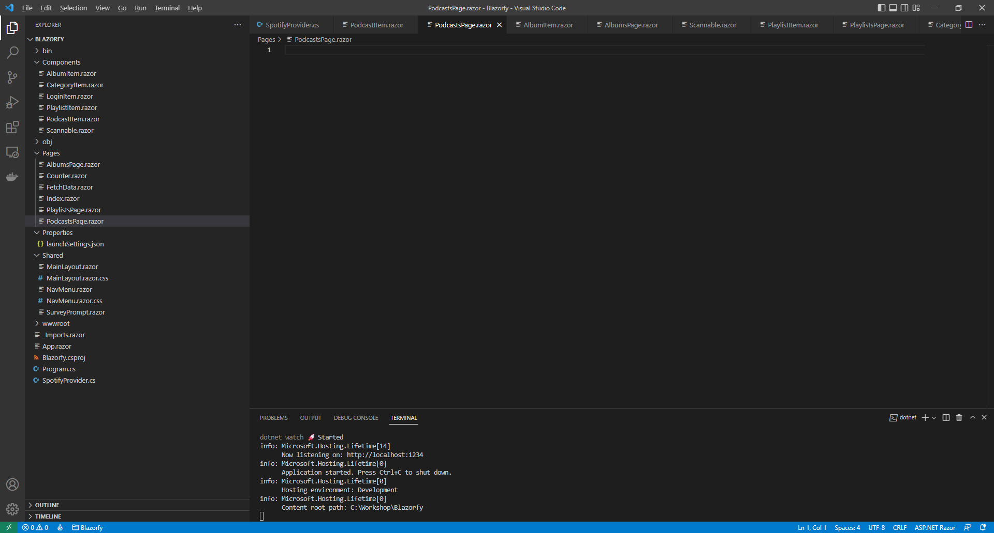

Within *PodcastsPage.razor* in **Visual Studio Code** you can define the entire **Page** by typing in the following:

@page "/podcasts"

@inject SpotifyProvider _provider;

<**LoginItem** **Value**="@_provider.IsLoggedIn" />

@if (_provider.IsLoggedIn)

{

// Items Output

}

@code

{

public List<SimplifiedShow> Items { get; set; } = new();

[Parameter]

[SupplyParameterFromQuery]

public string? Search { get; set; }

// Items Method

}

This **Page** includes a **page** directivewhich create a **Route** needed to navigate to this **Page** which will be used from the **Menu** later.

There is also an **inject** to provide the **Instance** of the **SpotifyProvider** using **Dependency Injection**. Then there is the **Component** of **LoginItem** with the **Value** being provided with the **Property** for **IsLoggedIn** from the **class**.

There is also the **Property** for **Items** to be displayed in the **Page** along with a **Property** for the **Search** that will be provided, which will be from a query to the page from a **Form** which is denoted with the **Attribute** of **SupplyParameterFromQuery**.

While still within *PodcastsPage.razor* in **Visual Studio Code** and below the **Comment** for **// Items Method** type the following **Method**:

protected override async Task OnParametersSetAsync()

{

Items.Clear();

if (await _provider.IsLoggedInAsync())

{

if (Search != null)

{

Items = await _provider.SearchAsync<SimplifiedShow>(Search);

}

}

}

This is a special **Method** where the implementation of which has been overridden to provide our own denoted with **override** in this case it is for **OnParametersSetAsync** and will populate the **List** of **Items** for the **type** of **SimplifiedShow** which represents a **Podcast** using the **Method** of **SearchAsync** and provide the value to this with **type** of **SimplifiedShow**.

Finally while still within *PodcastsPage.razor* in **Visual Studio Code** and below the **Comment** for **// Items Output** type the following:

<h1>Search @Search</h1>

<form @onsubmit="OnParametersSetAsync">

<input type="text" @bind="Search" @bind:event="oninput" />

<button class="btn btn-primary">Search</button>

</form>

<div class="container">

<div class="row row-cols-1 row-cols-md-4 p-2 g-2">

@foreach (var item in Items)

{

<div class="col">

<**PodcastItem** **Value**="@item" />

</div>

}

</div>

</div>

This defines how the **Page** will look, there is a **form** to perform a **Search** this has an **input** which is where the **Podcast** being looked for will be typed in and then there is a **button** to perform the **Search** and below this the **Component** for the **Podcast Item** will be used to display the **Podcasts**.

You can then go to the **Menu** in **Visual Studio Code** and select **File** and then **Save All** you may see in the **Terminal** a message saying **Do you want to restart your app - Yes (y) / No (n) / Always (a) / Never (v)?** you can select the **Terminal** then type **y** for **Yes** or **a** for **Always** to keep what you have done so far.

Then in **Visual Studio Code** from the **Explorer** for **Blazorfy** open **Shared** by selecting the **>** next to it in **Explorer** and select **NavMenu.razor** as follows:

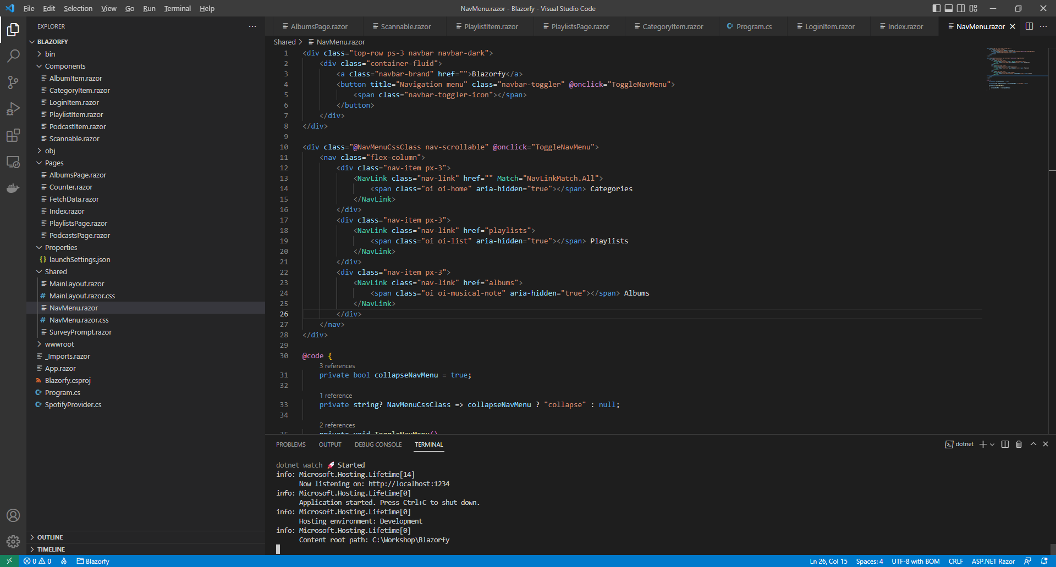

Then within *NavMenu.razor* after the **</div>** of the **Albums** section in the **Menu** shown below:

<div class="nav-item px-3">

<**NavLink** class="nav-link" href="albums">

<span class="oi oi-musical-note" aria-hidden="true"></span> Albums

</**NavLink**>

</div>

You can add **Podcasts** section to the **Menu** by typing in the following:

<div class="nav-item px-3">

<**NavLink** class="nav-link" href="podcasts">

<span class="oi oi-microphone" aria-hidden="true"></span> Podcasts

</**NavLink**>

</div>

You can then go to the **Menu** in **Visual Studio Code** and select **File** and then **Save All** you may see in the **Terminal** a message saying **Do you want to restart your app - Yes (y) / No (n) / Always (a) / Never (v)?** you can select the **Terminal** then type **y** for **Yes** or **a** for **Always** to keep what you have done so far.

If you return to the **Browser** you should be where you left off but there will now be an **Podcasts** option in the **Menu** as shown below:

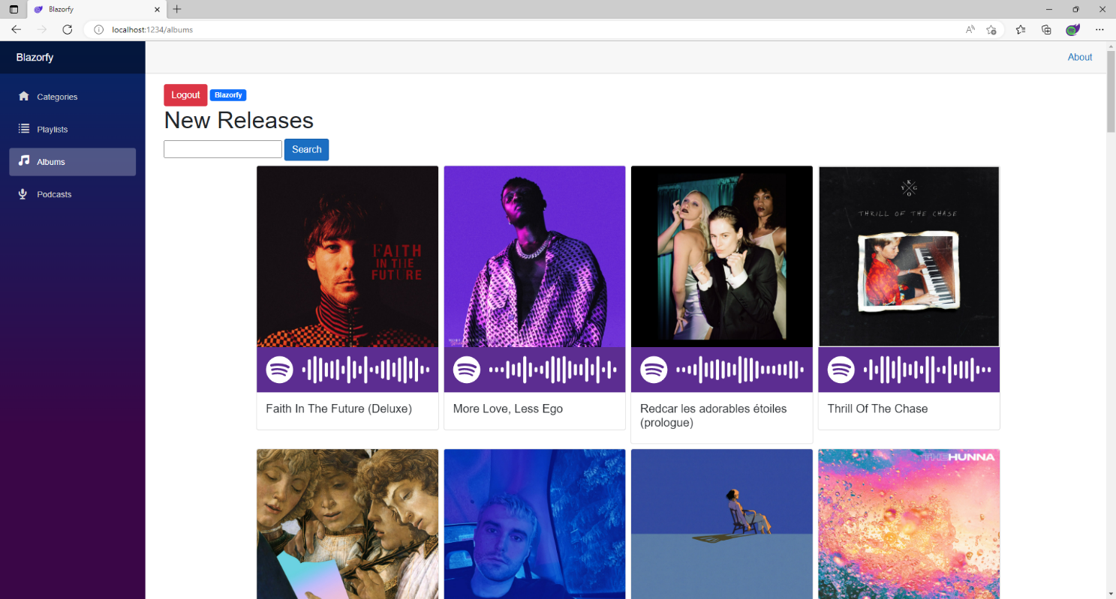

You can then select **Podcast** then search for your favourite and should see something similar to as follows:

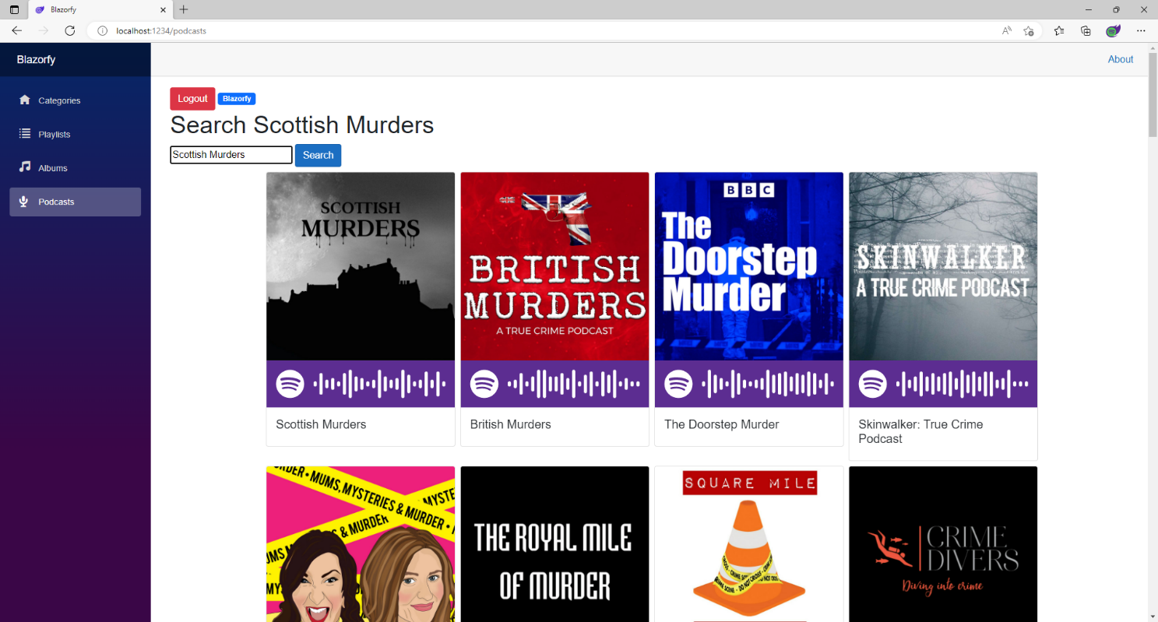

Again underneath each **Podcast** is a **Spotify Code**, if you have **Spotify** on your *iPhone* or *Android* device you can use the option to scan these using the app and can then subscribe to the **Podcast** yourself.

If you don’t see anything then check that you’ve completed each part correctly and double-check that what you have is the same and then you can **Logout** and **Close** the **Browser** and **Visual Studio Code**.

# Finish

## Blazor

**Blazor** allows you to build interactive client web applications composed using **C#**, **HTML** and **CSS** that supports both **Client** using **Web Assembly** and **Server** using **ASP.NET** created by **Microsoft**.

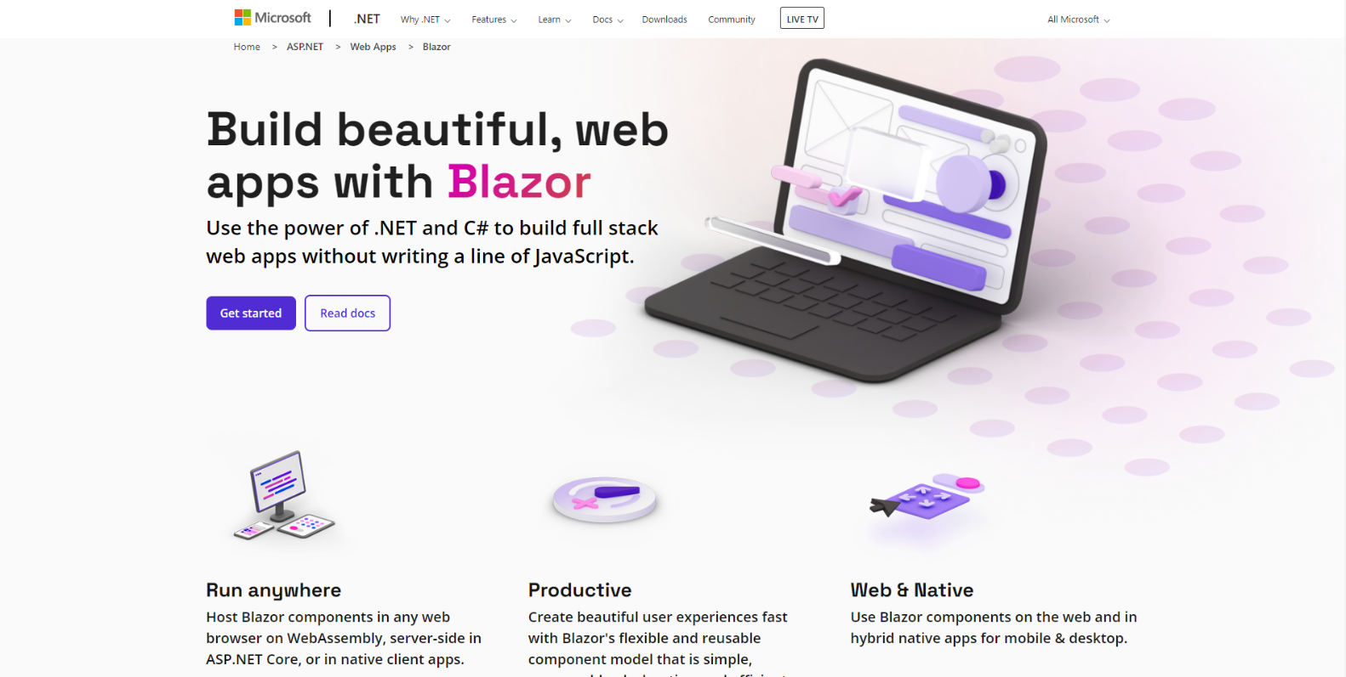

**Blazor** allows you to develop either for **Server** where events are passed using **SignalR** to the **Client** or you can run your **C#** code directly on the **Client** in the **Browser** using **WebAssembly** and you can even re-use code between **Server** and **Client**. You can find out more about **Blazor** including documentation, examples and more at [blazor.net](https://blazor.net).

## Spotify

**Spotify** is a music streaming service that allows you to discover and play a variety of **Music** and **Podcasts** from your *iPhone* or *Android* or other devices and a **Web API** for developers with **Spotify for Developers**.

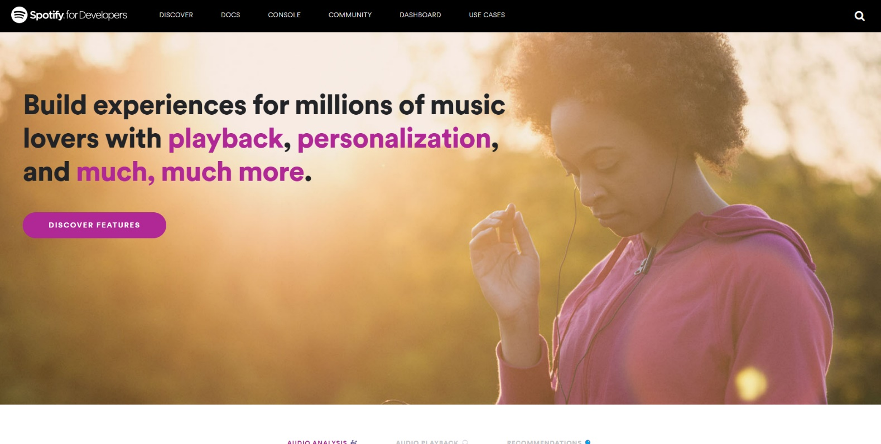

**Spotify for Developers** allows you to deliver your own experiences powered by a **Web API** for **Albums**, **Artists**, **Shows** and their **Episodes** along with **Audiobooks** and their **Chapters**. You can also **Search** content, show **User** information, manage **Playlists** and get **Categories** or **Genres**. You can also control playback with **Player** or see what **Markets** you can get **Spotify**.

**Spotify for Developers** uses a normal **Spotify** account and you can sign up for free and then set up **Apps** in the **Dashboard** to create the **Client Id** to use the service and as **Edit Settings** such as **Redirect URIs** or add up to 25 **Spotify** accounts for development, or when ready request an **Extension** to go public. You can find out more about **Spotify for Developers** and the **Web API** including documentation, examples, online console and more at [developer.spotify.com](https://developer.spotify.com/).

## Summary

**Blazor** is a powerful platform that allows you to create experiences in your **Browser** like **Blazorfy** using **Spotify** so you can see what you can do with it and leverage the power of the **.NET** platform in your applications, whether you’ve never written a single line of code until today, or had never heard or used **Blazor**, **.NET** or **C#** or you just wanted to try something new hopefully you’ve learned something today and you can go back over the **Workshop** and look up many of the concepts, but the best way is to try something small and grow from there, you can go from **Hello World** to **Blazorfy** in a couple of hours, where would spending more time take you? You’ll just have to find out!